Throws (Javelin & Shot)

Event Group Development Sessions

Athletics Northern Ireland will provide weekly throws development sessions delivered by Laura Kerr, GB&NI and Irish Team Coach and throws coach to European U20 Heptathlon Silver Medalist Kate O’Connor and Irish Universities Javelin record holder-Jack Magee.

Beginning in October sessions for athletes aged 14-19 years old will take place on a Saturday at Ulster University, Jordanstown. Closer to the competitive season these sessions are likely to move outdoors to Mary Peters Track.

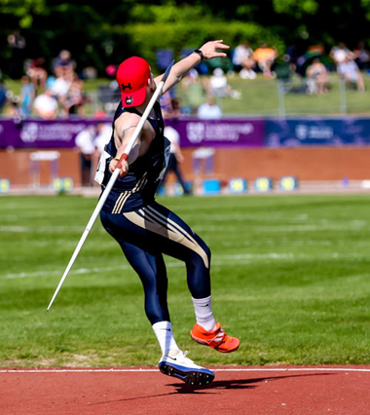

Athletics Northern Ireland aim to provide opportunities for teenage athletes to learn and train together on a regular basis and have upskilled a number of event specialist coaches to support this. Ultimately, we aim to see technically and physically well-prepared and robust young athletes progress to Youth Academy and on to represent Northern Ireland as senior athletes.

These sessions aim to bridge the gap to technical event specific training for Rising Stars athletes with multi events experience or schools’ athletes who have some experience and wish to train on a more regular basis for shot or javelin.

The training emphasis will develop through the year and with a later peaking age in throws long term athlete development will be kept in mind. Sessions for throwers will therefore include: a movement skill based warm up, plyometrics, medicine ball throwing, technical drills and sprints. There will also be an option to complete a strength development session immediately after the throws session at Ulster University.
- Sessions will take place between 12.30 and 4.30pm at a cost of £8 per session with 10-12 expected sessions in term 1 between the beginning of October and end of December. Were this is a key session for a Academy Athlete a fee waiver or discount will be organized. The start times for javelin throwers and shot putters may be slightly offset to allow for individual programming.

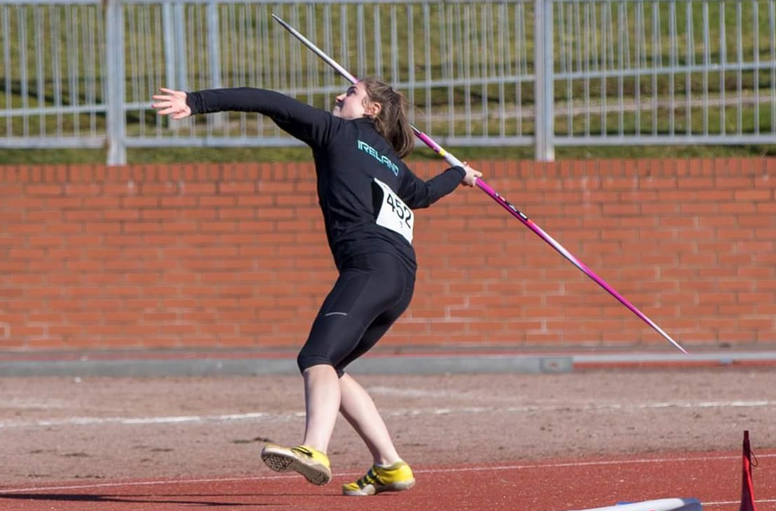

Application form

Please complete the following:

Name:
DOB:
School or University Year in September 2019:
Coach/Club (if any):
Home Town:
Training Experience or normal weekly training schedule;

Normal Training Location:
Main event
2017 PB: date;
2018 PB: date;
2019 PB: date;

Secondary Event
2017 PB: date;
2018 PB: date;
2019 PB: date;

After review of the applications that are received there will be a selection process and successful applicants will be contacted with further information so that they can pay the registration fee online and provide emergency contact details etc.

Spaces will be limited to allow us to meet ideal coach to athlete ratios for technical events and applications will be assessed based on performance, potential and availability to engage. Where an athlete already works with a throws coach but wishes to supplement their normal training with this specialist session they should first speak to their coach about it. Coach-athlete pairs who would like to attend together to follow the training plan, upskill and benefit from working together in a group are welcome to apply and make note of this when completing the form above.

Applications may be typed or handwritten but must be either emailed to laura@thleticsni.org or alternatively posted to arrive by 6pm 23rd September 2019 to:

Laura Kerr

Athletics House,

Old coach Road,

Belfast

BT9 5PR

