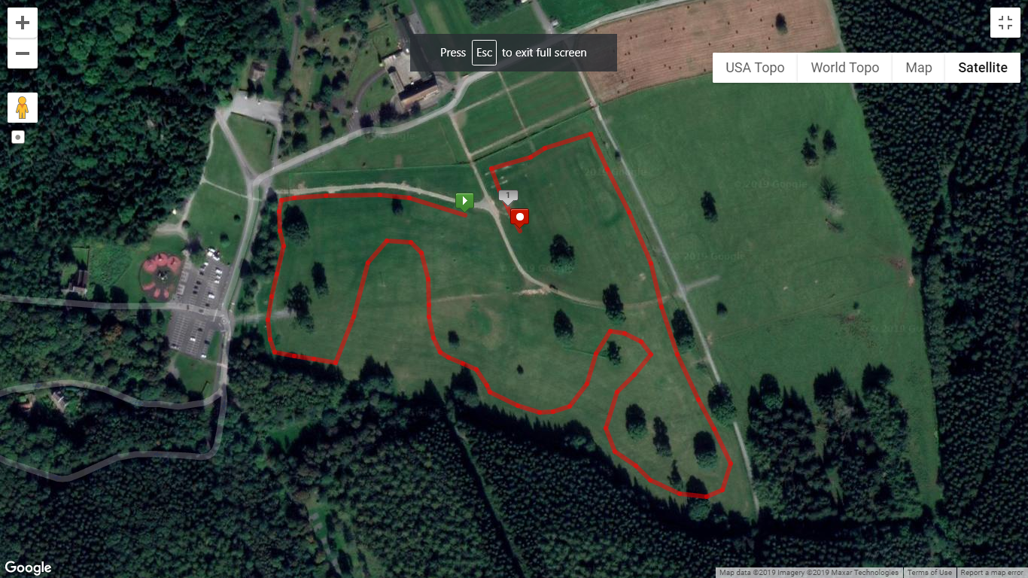

CHANGING FACILITIES &

REGISTRATION

CAR PARKING

**1 LAP = 1600m – DISTANCE IS APPROXIMATE\***

Women’s and M60’s Race – 4750m – 3 Full Laps

Men’s Race – 8000m – 5 Full Laps

FINISH

START