

***ACADEMY 2022-23***

***APPLICATION PACK***

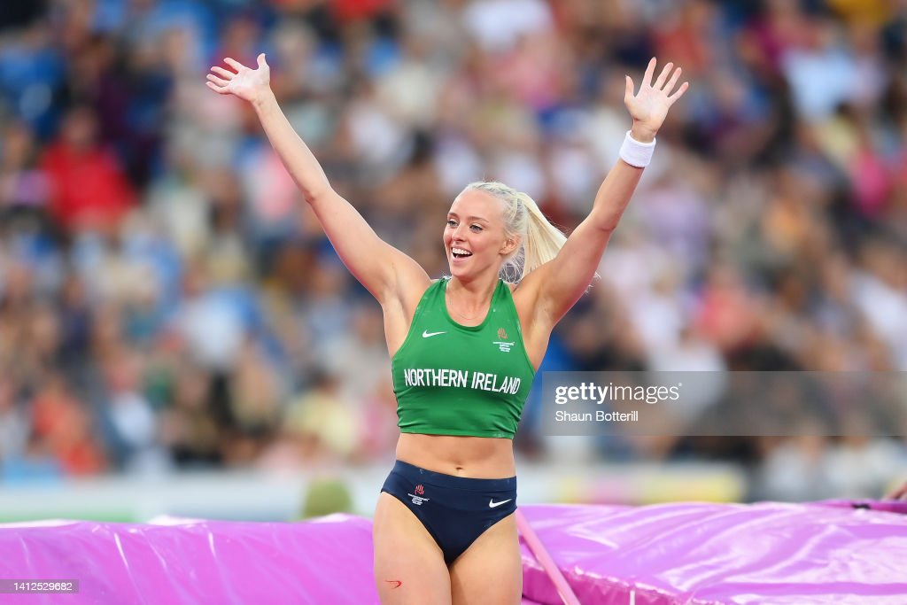

***NURTURING JUNIOR TALENT***

***ASPIRING TO SENIOR SUCCESS***

**VISION**

In September 2014 Laura Kerr and Tom Reynolds launched the Athletics Northern Ireland Youth Academy to support Northern Ireland’s most talented young athletes and their coaches.

“***We believe physical & technical preparation and a performance mindset are critical for athlete development and we must create a challenging, supportive, open and professional environment where athletes and coaches can fulfil their potential.***”

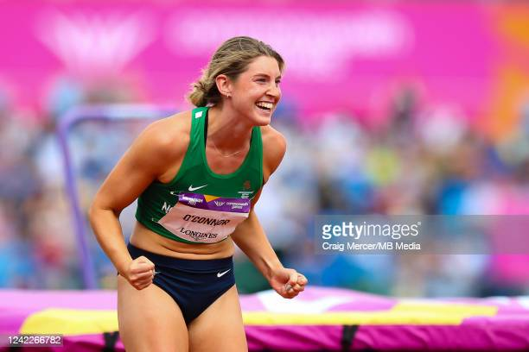Athletics Northern Ireland's Academies aim to identify and develop talented junior athletes and raise their potential for senior success. We are focused on improving physical qualities, sporting knowledge, psychological skills and performance behaviours in young athletes whilst educating parents and coaches on what it takes to perform consistently on the international stage as seniors. In doing so we believe Northern Ireland will develop a pipeline of junior athletes who will become successful seniors representing Northern Ireland at the Commonwealth Games and Great Britain or Ireland at major championships.

“***British Athletics have invested into the talent systems of each home country since 2019 and again for 2022-23 in order to increase the pipeline of Northern Ireland athletes who will go on to achieve senior success at major championships”***



**SUCCESSES**

Since establishing the Academy in 2014 supported Athletes have achieved Commonwealth Youth Games Medals, European Junior Medals & World Para Medals & made breakthroughs to compete at European Team Championships, Senior Commonwealth Games, European & World Indoors.

***5 Graduates of Youth Academy competed at the 2022 Commonwealth Games in Birmingham***

***27 Northern Ireland U20 & U18 Records were broken between 2015-2022*.**

2022 saw record breaking performances from Academy athletes with Nick Griggs becoming European U20 record holder for the indoor mile and NI U20 3000m record holder. Finn O’Neill became NI’s top U18 Decathlete of all time.

European Cross-Country Championships were held in Dublin in December 2021 with 3 Academy athletes selected to represent Ireland on the U20 team with one athlete winning a silver medal in the team event.

The summer season saw 3 major championship opportunities for junior athletes with 2 NI athletes being selected to represent Ireland at the European Youth Olympic festival in Slovakia, 3 at the European U18 Championships in Jerusalem and 3 at the World U20 Championships in Colombia.

The Youth Academy availed of 99,000 Euros from the EU’s Erasmus+ scheme and used this for Academy athlete and coach warm weather training camps in Portugal at Halloween 2021 and Easter 2022.

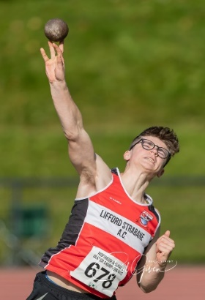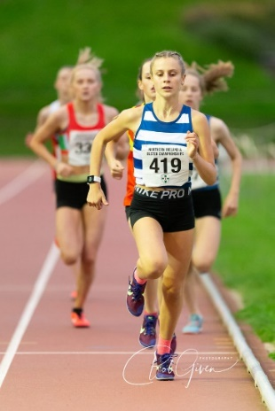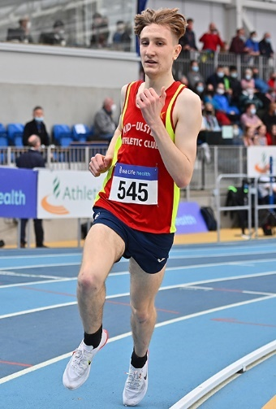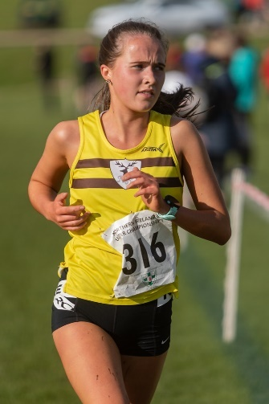



**ACADEMY STRUCTURE & SUPPORT FOR 2021-22**

In September 2022 athletes aged under 22 years old will be eligible to apply to either:

* **Youth Academy** (for NI’s most talented Eligible Athletes aged between 15-21 years old)
* 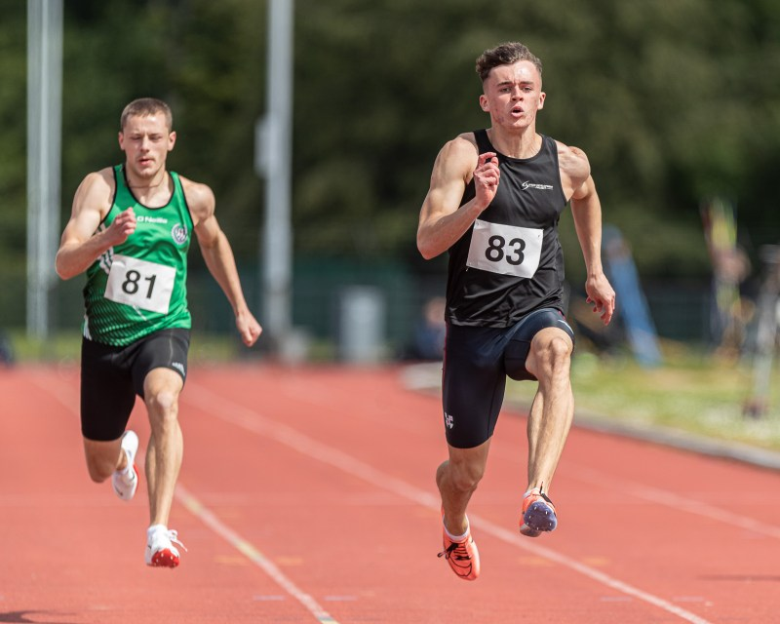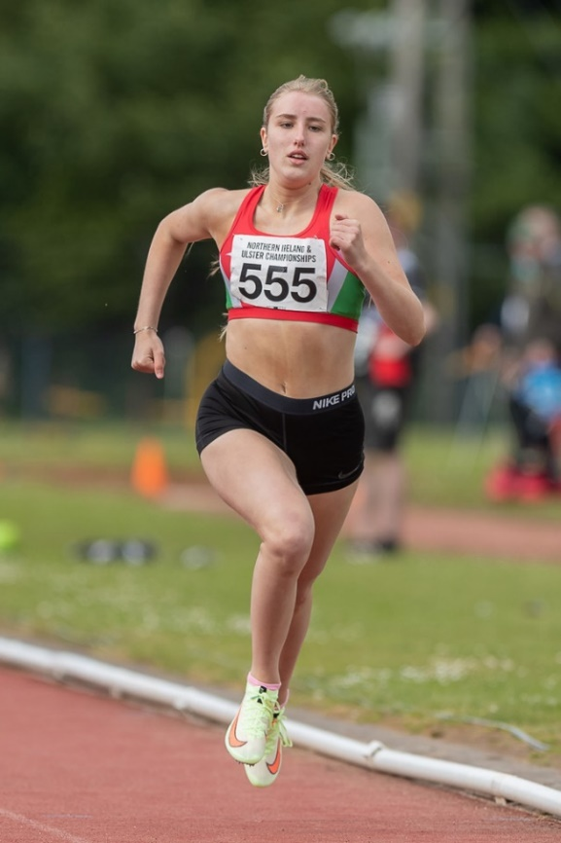**Speed Power Academy** (NI *and Ulster* Eligible Athletes aged 14-18 years old.) This will suit athletes aspiring to future Youth Academy selection.



|  |  |
| --- | --- |
| * **Weekly Speed Development** | * **Weekly Speed Development** |
| * **Weekly Strength and Conditioning** | * **Weekly Strength and Conditioning** |
| * **Quarterly Strength Diagnostics and profiling** | * **Quarterly Strength Diagnostics** |
| * **Integrated Physiotherapy Clinics** | * **Movement Screening** |
| * **Athlete, Parent and Coach Education** | * **Athlete, Parent and Coach Education** |
| * **Easter Warm Weather training camp for new athletes with additional bursaries for athletes on the cusp of EYOF, European U20 or Commonwealth Youth Selection** |  |
|  |  |

**YOUTH ACADEMY SERVICES**

The Athletics Northern Ireland Youth Academy has proven popular and successful and now has bases at Jordanstown and Coleraine delivering weekly physical preparation and athlete education sessions. Delivery will recommence at both bases in October 2022.

Youth Academy will offer the following support dependant on relevance to the athlete-coach pair applying:

* **A launch weekend on Sunday 30th October 2022** at Ulster University Jordanstown where athlete and coaches will attend for baseline physiotherapy/ movement screening and strength diagnostics assessment to assist with goal setting and planning for the upcoming year.
* **A half term camp on Sunday 19th February 2023** at Ulster University Jordanstown
* **Weekly sessions** commencing on the week beginning 17th October 2022 focused on speed development, strength & conditioning and plyometrics
* **Bespoke Athlete and coach education** sessions focusing on nutrition, recovery, planning, mindset etc
* **A Warm Weather Training Camp** in Portugal at Easter for new Youth Academy athletes. Final selection for these will take place 6 weeks prior to camps and will depend on priority competitions, progress, engagement and appropriateness of training partners on camp. Bursaries will be made towards athletes who have travelled before but are tracking towards EYOF, European U20 Championships or Commonwealth Youth Games in 2023.
* **Monthly / fortnightly physiotherapy clinics** with Academy physiotherapists Anna Lawther (Jordanstown) and Stephen Haslam (Coleraine) with some discretionary 1-1 physiotherapy support based on need.
* A handful of Youth Academy Athletes who are clearly tracking toward major championships may be able to access increased planning support or some discretionary funding for targeted competitions as the year progresses. This will be specific to their own targets.

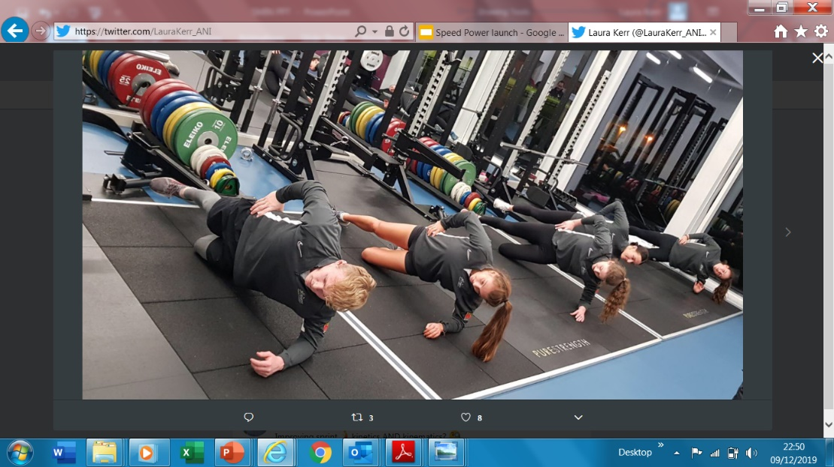

**SPEED -POWER ACADEMY**

The Speed - Power Academy, delivered at Ulster University Jordanstown and launched in 2018, was established to expose athletes aged 14-18 years old from all events (sprints, jumps, endurance and throws) and their coaches to the basic physical preparation concepts behind the Youth Academy. The aim is to help young athletes transition successfully to event group training and ideally, for those who are NI eligible - the Youth Academy.

***“This academy will help support athletes from the additional 3 counties of Ulster as well as those resident in NI. Athletes will be supported with weekly speed development and strength and conditionings sessions led by Athletics NI staff.”***

Support this year will include 2 half day camps at Ulster University Jordanstown in October and February and bespoke educational workshops as well as an introductory movement screen and feedback for each coach. Monitoring via electronic timing and force plates for strength diagnostics will be ongoing throughout delivery with timely feedback to coaches.

**ELIGIBILITY**

To be eligible for:

* **Youth Academy**… an athlete must be eligible for NI Commonwealth Games selection by either being born in NI, having at least 1 parent or grandparent born in NI or having 3 years residence in NI.
* **Speed - Power Academy**… an athlete must be either NI eligible (as above) or Ulster eligible (from one of the additional 3 counties of Ulster.)

**RETENTION**

The Youth Academy is designed to deliver a 3-year curriculum and, during the past 2 years the majority of athletes residing in NI were retained in the Academy due to the impacts of Covid 19 on their Academy programmes. It is expected that for 2022-2023 there will be competitive applications from a number of new athletes and spaces are not guaranteed for athletes reapplying who have not shown upward progress. Occasional extensions are made for an athlete who has entered very young and would benefit from an additional year of support to assist with their first-year transition to university or work post 18. Where an athlete is clearly on a trajectory towards future Commonwealth Games and Youth Academy inclusion would help them to bridge the gap to the Athletics NI Commonwealth Potential Squad their time in the Academy may be extended beyond 3-4 years.

**All athletes must re-apply each year**. We will aim to retain athletes who may not have progressed their performance after year 1 but, where performances are declining or plateaued for consecutive years, Athletics NI may need to consider exiting an athlete in order to allow capacity for another to utilise the services.

The Speed-Power Academy is designed to deliver a 2-year curriculum with the hope that NI eligible athletes may progress to Youth Academy. Those aiming to progress from Speed Power Academy to Youth Academy will still be assessed on performance standards and compared against all other applicants. Those showing progress in Speed Power Academy after year 1 are most likely to be retained for another year. After 2 years in the Speed Power Academy athletes who have not progressed to Youth Academy will still have new knowledge, skills and abilities to support them in working with their personal coach.

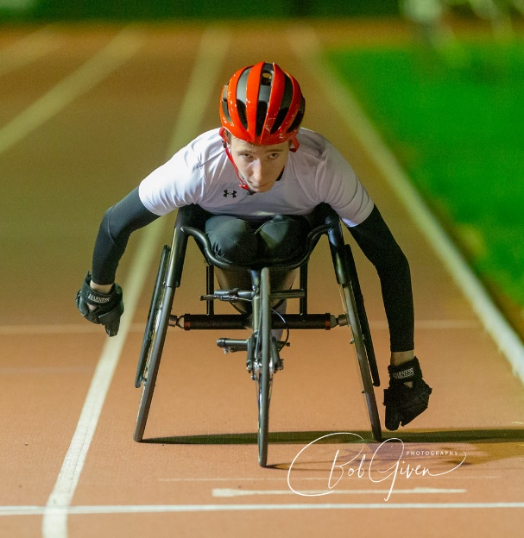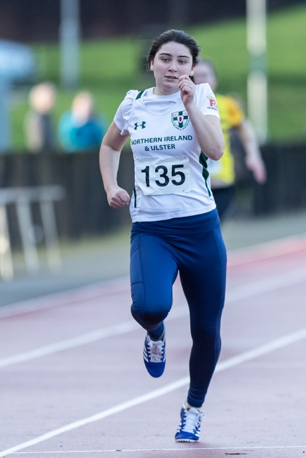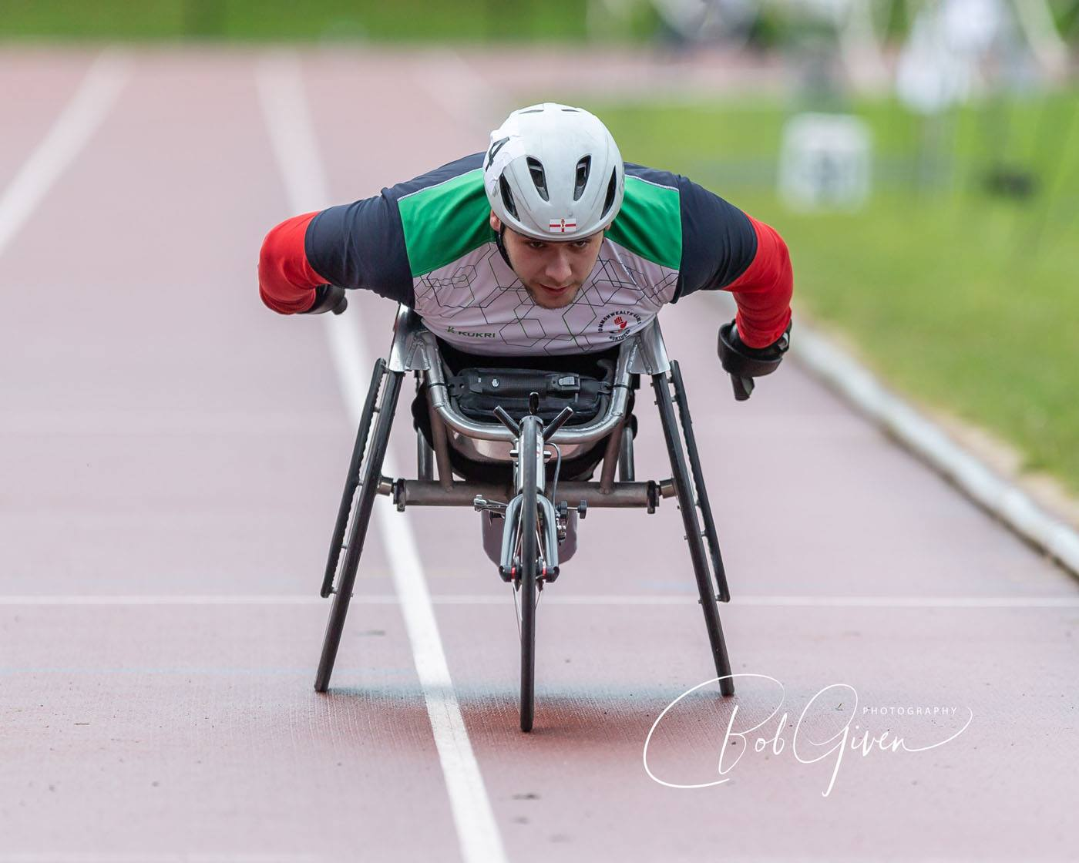

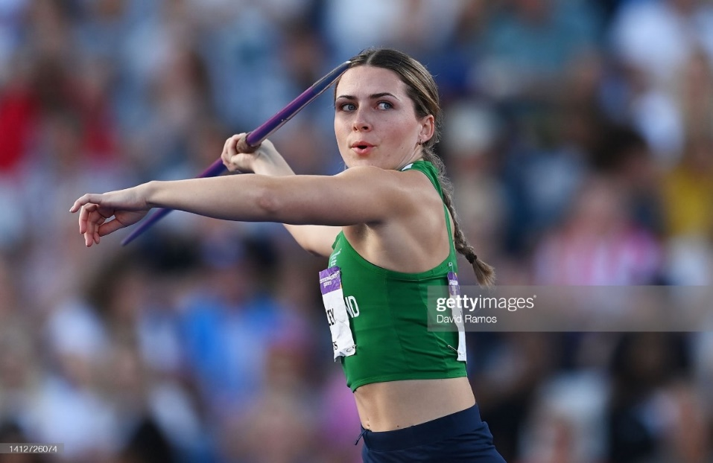

**LOOKING BEYOND YOUR ACADEMY EXPERIENCE**

The aim of our academies is to enhance the sporting knowledge, physical and psychological skills and performance behaviours of athletes to better equip them to undertake senior training with their personal coach in future.

***“The academies are not designed to provide ongoing facilities access, strength and conditioning or physiotherapy support through an athlete’s senior career but instead to equip athletes and coaches with the skills they need to maximize their use of these services elsewhere as a pair.”***

Youth Academy staff will support athlete transitions for those leaving Northern Ireland for university. Staff will also support other Academy exits by meeting with athlete-coach pairs to discuss next steps and areas for progress. We will help you identify what level of performance will be required for inclusion on the Commonwealth Potential Programme and discuss how athletes can best tap into the support personal coaches, clubs and universities offer.

***“Inevitably not all Youth Academy Athletes will make the Commonwealth Potential Programme but the Academy systems are designed to create upward pressure on the pathway and increase the number who do. By raising the potential of athlete-coach pairs we will increase the probability that talented juniors will progress to a Major Championships whilst also increasing the quality of national level athletes for Northern Ireland teams.”***

* **Kate O’Connor – Commonwealth Games Silver medallist, Birmingham 2022** remains in Ireland and has been supported by the Commonwealth Potential Programme and then Olympic potential programme since winning a European Junior medal in 2019.
* **Ellen McCartney -** moved initially to Brunel University (2018) and has been included on the Commonwealth Potential Programme since 2020. In 2022 Ellie raised her pb to 4.25m at the Birmingham Commonwealth Games achieving 7th place.
* 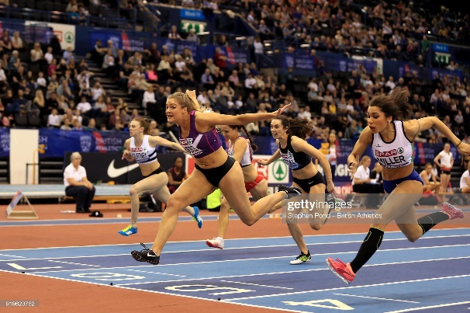**Megan Marrs -** moved to Loughborough University (2016) and has been supported by the Commonwealth Potential Programme since the age of 20. In 2022 Megan won the British Indoor Championships and was selected to represent GB&NI at the European Indoor Championships. Megan also represented NI at the Birmingham Commonwealth Games.

**STAFF**

* **Laura Kerr is the Talent Lead for Athletics NI** and will drive the vision for talent projects and shape the curriculum.
* **Amy Foster is the Academies Manager for Athletics NI** and is responsible for Academy delivery and effective communication with athletes, coaches and parents.
* **Tom Reynolds is the Performance Lead for Athletics NI** and will oversee athlete transitions to commonwealth programme
* **Scott Paulin, Athletics NI Pathways Coach** delivers on weekly speed development and strength and conditioning.
* **Anna Lawther (Jordanstown) and Stephen Haslam (Coleraine) are the Academy Physiotherapists** and will support the delivery of weekly Strength & Conditioning, Speed Development and Injury Prevention Clinics.

**SHARED VALUES**

**Ambition –** we aim to make a lasting impact on the sport for Northern Ireland and will seek out new and innovative opportunities to do so.

**Challenge –** we believe a high challenge-high support environment will achieve the best outcomes for junior athletes.

**Consistency –** We will consistently deliver world class physical preparation, injury prevention and education utilising all of the professional expertise available to us. Even the best system in the world would not be impactful if it were only executed 70% of the time.

**Performance Mindset –** We know athletes will require high level psycho-social skills as well as physical skills to succeed as seniors and we will facilitate the development of these through our interactions with them.



**ANNUAL DELIVERY** - **2022-2023 DATES**

|  |  |
| --- | --- |
| **17th October 2022** | Weekly delivery begins |
| **30th October 2022** | Launch and baseline day at Ulster University Jordanstown |
| **21st December 2022-5th January 2023** | Christmas break |
| **6th January 2023** | Weekly delivery recommences |
| **19th February 2023** | Half term camp at Ulster University Jordanstown |
| **5th April – 14th April 2023** | Easter break |
| **17th April 2023** | Weekly delivery recommences |
| **30th June 2023** | Academy term 3 ends / Speed Power Academy ends |
| There will be a further 6 weeks of Youth Academy delivery for Monday/Tuesday/Wednesday sessions over the summer months ending on 12th August.  There will be no Friday delivery after 30th June due to weekend competition schedules. | |

**WEEKLY DELIVERY**

|  |  |  |
| --- | --- | --- |
| **YOUTH ACADEMY** | | |
| **Monday** | **Jordanstown**  **5pm-7pm** | A small group of Academy athletes will be able to attend for speed development and S&C |
| **Tuesday** | **Jordanstown**  **6pm-9pm** | This is the primary Youth Academy session that the majority of athletes will need to attend.  Speed development, S&C and physiotherapy clinics delivered. Athletes typically attending for 2 hours minimum. |
| **Wednesday** | **Coleraine**  **5pm-7.30pm** | Speed development and S&C |
| **Friday** | **Jordanstown**  **4.30pm-6.30pm** | Speed Development and S&C. This may be the primary session for some Academy athletes who cannot attend on Tuesday or a secondary session for others |
| **SPEED POWER ACADEMY** | | |
| **Friday** | **Jordanstown**  **5.30pm-7.30pm** | Speed Development and S&C with occasional education workshops delivered on Friday evenings at UUJ or on Zoom. Athletes should not apply for this Academy if they cannot attend at these times as there are no other options. |

**Athletes may apply to join the Youth Academy even if they are not available to attend weekly sessions however they must demonstrate clear rationale and willingness to engage with athlete, coach and parent education sessions and injury prevention elements of the programme. Programming for remote S&C may be requested if clear need is demonstrated.

**WARM WEATHER TRAINING**

Erasmus+ funding is available for 20 unique athletes to attend Erasmus+ warm weather training camp at Easter 2022. Bursaries may be provided for athletes who have received a funded place before but are tracking towards a major championship in 2023 – European Youth Olympic Festival (U18), European U20 Championships, Commonwealth Youth Games (U18).

**FEES**

For successful applicants the athlete fees for inclusion in the Academies 2022-2023 are

|  |  |  |
| --- | --- | --- |
|  | **2021-2022 FEE** | **NOTES** |
| **YOUTH ACADEMY JORDANSTOWN** | **£250** | This fee includes weekly S&C, Speed Development Sessions, access to physiotherapy clinics at UUJ, screening at the Halloween Launch Day and Half Term Camp. Athletes who do not plan to attend weekly but wish to access educational and camp elements or remote S&C programming and strength diagnostics can contact [**amy.foster@athleticsni.org**](mailto:amy.foster@athleticsni.org) to discuss the possibility of a fee reduction. |
| **YOUTH ACADEMY COLERAINE** | **£180** | The reduced price at YA Coleraine compared to UUJ is due to fewer weekly training options being available at Coleraine. The high cost of indoor track use at Jordanstown also increases the cost there. |
| **SPEED POWER ACADEMY JORDANSTOWN** | **£220** | This includes weekly S&C and speed development. 2 half term camps at Halloween and February half term including movement screening, strength diagnostics, coach feedback and educational workshops. |

**Electronic payment will be requested when weekly delivery commences.**

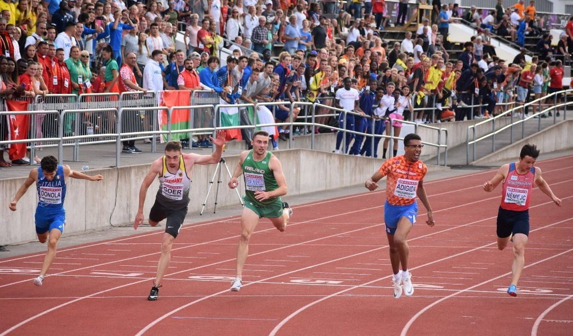



**APPLICATION & SELECTION**

The academies aim to support athletes and coaches who have identified their own strengths, weaknesses and areas for progress and who will benefit most from engaging with the physical preparation, physiotherapy and performance lifestyle support available. Selection will prioritise athletes who demonstrate the potential and ability to eventually represent Northern Ireland at a Senior Commonwealth Games.

**Selection Criteria**

There are no specific entry standards for Academy Selection as limited Academy capacity means athletes across all events must be compared.

Athletes will be assessed for inclusion based upon their performance standards and performance potential.

**Performance**

* Track and Field performances be assessed by comparison to European Athletics Minimum Championship Standards for European U18, U20 and U23 Championships. Consideration for road, cross country and mountain running performances will be made.
* Performance levels will also be compared to Power of 10 Rankings and Power of 10 Top 10 Targets. These Power of 10 targets will be especially useful in considering U16 athletes who cannot be compared to European Athletics U18 standards.

**Potential**

* Potential for senior success will also be considered. Coaching partnership, commitment to the sport, maturation, peaking age for event, demonstration of ability and mindset to access support available will all be considered. The selection panel will discuss:
  + - Coaching relationship and training environment
    - Use of Academy services to date
    - Training history
    - Training gaps
    - Motivation
    - Commitment to athletics and balance with other sports
    - Coach engagement
    - Injury history
    - Availability and mindset to engage with the programme for maximum impact

The selection panel will also discuss maturation, peaking ages in different event groups and impact on performance trajectory.

**SELECTION PROCESS**

1. Athletes who apply will be compared to each other based on performance, potential and ability to engage with the programme.
2. Athletes will then be ranked in priority order for selection to the academies.
3. Athletes will be offered places in Academies based on total capacity.

**APPLICATION**

Athlete -Coach pairs should meet to complete the online application form by 5pm Friday 23rd September 2022.

We recommend that athlete and coach discuss the completion of this form and parents of U18 athletes are closely involved in the application process.

**A panel will deliver the selection process on the week commencing 26th September 2023. All applicants will receive communication by Wednesday 5th October 2023.**

**COMPETITIONS IN 2022-23**

**Major Championships on the horizon for athletes aged 15-22 years old include…**

* European Cross Country, Turin (Italy) 11th December 2022
* European U20 Championships, Cluj-Napoca (Romania) 6th-9th July 2023
* European U23 Championships, Espoo (Finland) 13th-16th July
* European Youth Olympic Festival, Maribor (Slovenia) 23rd-29th July 2023
* Commonwealth Youth Games (U18) Trinidad and Tobago, Dates TBC

**Normal annual delivery would also see NI/NI & Ulster Teams be invited to**

* UK School Games (U17) September 2023
* Manchester international – typically August

**High Performing Individual Athletes may be offered bursaries to attend**

* British Milers Club meetings
* England Championships U17, U20 or U23 Championships
* Applicable European Permit meetings

