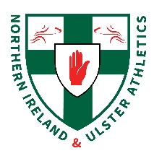
NI & Ulster 10,000m & Relay Championships
Saturday 20th August 2022
Mary Peters Track
Provisional Timetable
Time | Event
10am | Registration
11am | 10,000m Men & Women
12noom (4x100m) | U13 Girls Final
 | U13 Boys Final
 | U15 Girls Time Trials
 | U15 Boys Final
 | U17 Boys Final
 | U17 Girls Final
 | Senior Women Final
 | Senior Men Final
1pm (4x300m) | U15 Girls Final
 | U15 Boys Final
 | U17 Girls Final
1:45pm (4x400m) | U17 Boys Final
 | Senior Men Final
 | Senior Women Final

*Please note this is a provisional timetable only, and will be subject to change.

