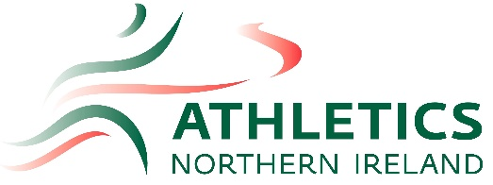
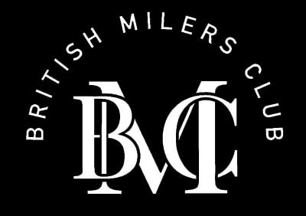

British Milers Meet
Wednesday 19th July 2023
Mary Peters Track

Track |  | Field
Time | Event | Time | Event
6:30pm | Women’s 400m Invitational | 6:30pm | Women’s Hammer Invitational
6:40pm | Men’s 400m Invitational
6:50pm | Men’s 1500m C Race
7:00pm | Men’s 1500m B Race | 7:00pm | Women’s High Jump Invitational
7:10pm | Men’s 1500m A Race
7:20pm | Women’s 1500m
7:30pm | Women’s 100m Invitational
7:35pm | Men’s 100m Invitational
7:45pm | Men’s 800m D Race
7:50pm | Men’s 800m C Race
7:55pm | Men’s 800m B Race
8:00pm | Men’s 800m A Race | 8:00pm | Men’s Javelin Invitational
8:05pm | Women’s 800m B Race
8:10pm | Women’s 800m A Race
 |  | 8:15pm | Women’s Long Jump Invitational
8:20pm | Men’s 3000m B Race
8:35pm | Men’s 3000m A Race
8:50pm | Women’s 3000m
9:15pm | NI Mixed 4x400m Relay Championship

