ACADEMY 2021-22
UPDATES & APPLICATION PACK

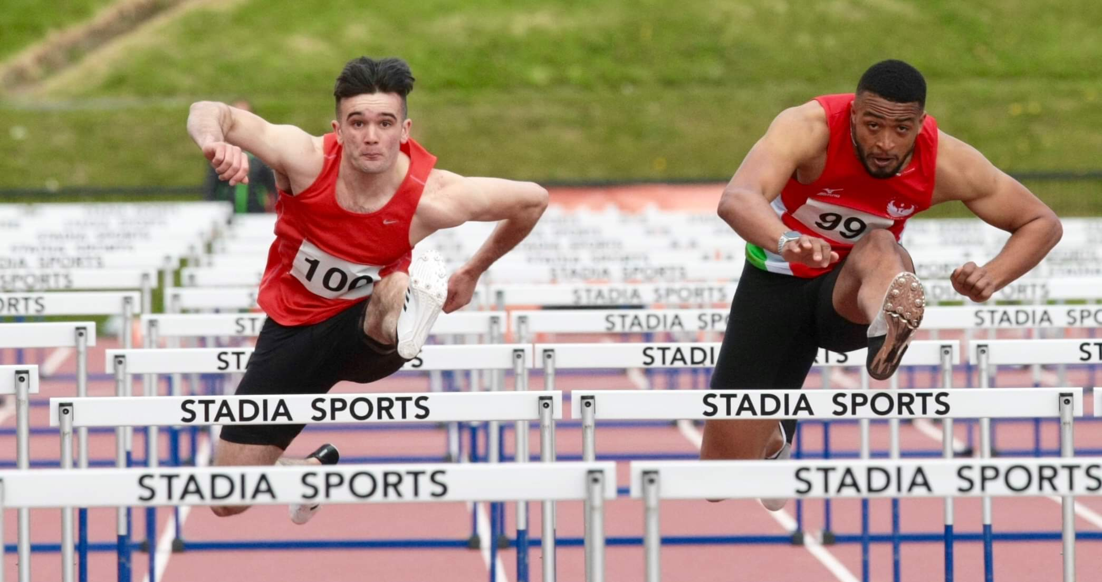

NURTURING JUNIOR TALENT
ASPIRING TO SENIOR SUCCESS

VISION
In September 2014 Laura Kerr and Tom Reynolds launched the Athletics Northern Ireland Youth Academy to support Northern Ireland’s most talented young athletes and their coaches.

“We believe physical & technical preparation and a performance mindset are critical for athlete development and we must create a challenging, supportive, open and professional environment where athletes and coaches can fulfil their potential.”

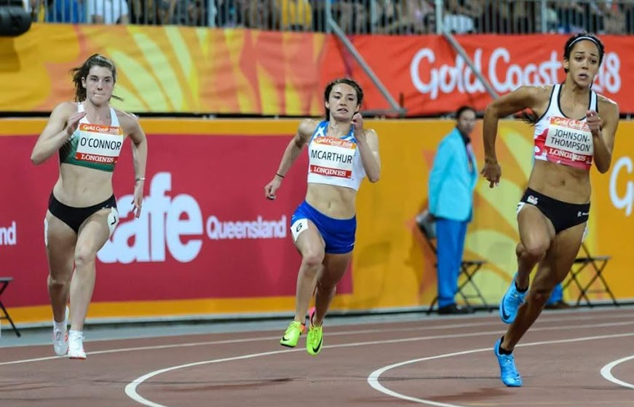
Athletics Northern Ireland's Academies aim to identify and develop talented junior athletes and raise their potential for senior success. We are focus on improving physical qualities, sporting knowledge, psychological skills and performance behaviours in young athletes whilst educating parents and coaches on what it takes to perform consistently on the international stage as seniors. In doing so we believe Northern Ireland will develop a pipeline of junior athletes who will become successful seniors representing Northern Ireland at the Commonwealth Games and Great Britain or Ireland at major championships.

SUCCESSES
Since establishing the Academy in 2014 supported Athletes have achieved Commonwealth Youth Games Medals, European Junior Medals & World Para Medals & made breakthroughs to compete at European Team Championships, Senior Commonwealth Games, European & World Indoors.

24 Northern Ireland U20 & U18 Records were broken between 2015-2021.

2019 saw more NI U20 athletes achieving Power of 10 top 10 targets than any other year since Power of 10 data collection began in 2006. COVID-19 brought significant disruption to training and competition in 2020 and 2021. Junior athletes overcame difficulties with 5 selected for the European U23 Championships and 4 selected for the European U20 Championships in Estonia.
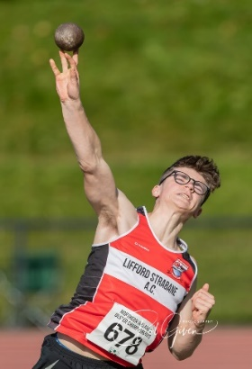
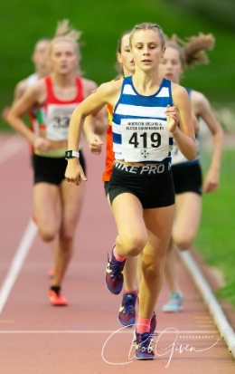
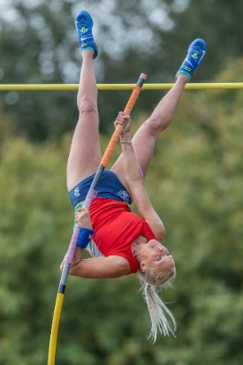

ACADEMY STRUCTURE & SUPPORT FOR 2021-22
In September 2021 athletes aged under 22 years old will be eligible to apply to either:
- Youth Academy (for NI Eligible Athletes aged between 15-21 years old)
- Youth Academy Hub (for NI Eligible Athletes aged between 15-21 years old who are specifically pursuing the British Pathway.)
- Speed Power Academy (NI and Ulster Eligible Athletes aged 14-18 years old.)

YOUTH ACADEMY | YOUTH ACADEMY  HUB | SPEED-POWER ACADEMY
- Speed Development  - Strength & Conditioning  - Strength Diagnostics  - Integrated Physiotherapy  - Warm Weather Training  - Athlete, Parent and Coach Education | - Profiling, Monitoring & Annual Planning  - Speed Development  - Strength & Conditioning  - Strength Diagnostics  - Integrated Physiotherapy  - Warm Weather Training  - Athlete, Parent and Coach Education |  | - Speed Development  - Strength & Conditioning  - Strength Diagnostics  - Movement Screening  - Athlete, Parent & Coach Education Workshops
YOUTH ACADEMY

The Athletics Northern Ireland Youth Academy has proven popular and successful and now has bases at Jordanstown and Coleraine delivering weekly physical preparation and athlete education sessions. Delivery will recommence at both bases in October 2021.

Youth Academy will offer the following support dependant on relevance to the athlete-coach pair applying:

- A 2021-22 launch weekend at Halloween where athlete and coaches will attend for baseline physiotherapy/ movement screening and strength diagnostics assessment to assist with goal setting and planning for the upcoming year.
- Weekly Speed Development Sessions
- Weekly Strength & Conditioning Sessions
- Weekly Plyometrics sessions
- Bespoke Training Diaries
- Bespoke Athlete and coach education sessions focusing on nutrition, recovery, planning, mindset etc
- A Warm Weather Training Camp in Portugal at either Halloween or Easter (dependant on Foreign Office advice relating to Covid 19 restrictions and vaccinations.) Final selection for these will take place 6 weeks prior to camps and will depend on priority competitions, progress, engagement and appropriateness of training partners on camp.
- Monthly / fortnightly physiotherapy clinics with some discretionary 1-1 physiotherapy support based on need
- Other benefits in the past have included sponsored products including Dale Farm Protein Milk Protein & Youth Academy Kit sponsored by Little Rays Nursery. Sponsor benefits for 2021-22 have not yet been arranged.
- A handful of Youth Academy Athletes who are clearly tracking toward major championships may be able to access increased planning support or some discretionary funding for targeted competitions as the year progresses. This will be specific to their own targets.
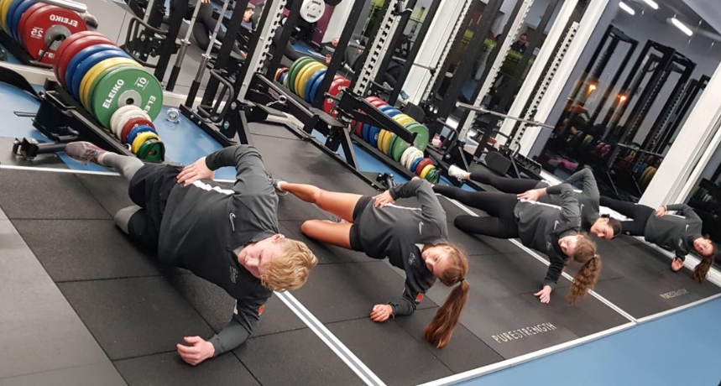

YOUTH ACADEMY HUB
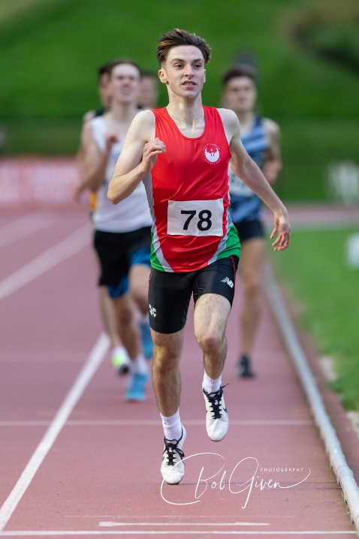
This core group within the Youth Academy was established in 2019, made possible by an investment from British Athletics.

“British Athletics have invested into the talent systems of each home country again for 2021-22 in order to increase the pipeline of U23 athletes achieving the standards for the British Futures Academy and going on to represent GB & NI at major championships. Their continued investment will allow enhanced and bespoke support for 3-6 selected Youth Academy Athletes who are eligible and pursuing future selection for Great Britain & NI.”

This enhanced support will include additional profiling, strength and conditioning support, communication with a British Athletics point of contact, support with individualized planning and the possibility of additional physiotherapy or competition support based on ongoing needs analysis.

**Entry into the Youth Academy Hub does not commit the athlete to representing GB&NI and the athlete would still remain eligible for either GB & NI or Ireland until accepting selection for a future major championship.

ULSTER UNIVERSITY SPEED -POWER ACADEMY
The Speed - Power Academy delivered in conjunction with Ulster University and launched in 2018 was established to expose athletes aged 14-18 years old from all events (sprints, jumps, endurance and throws) and their coaches to the basic physical preparation concepts behind the Youth Academy. The aim is to help young athletes transition successfully to event group training and ideally, for those who are NI eligible - the Youth Academy.

“This academy will help support athletes from the additional 3 counties of Ulster as well as those resident in NI. Athletes will be supported with weekly speed development and strength and conditionings sessions led by Athletics NI staff.”

Additional support this year will include a minimum of 3 bespoke educational workshops as well as an introductory movement screen and feedback for each coach. Monitoring via electronic timing and force plates for strength diagnostics will be ongoing throughout delivery with timely feedback to coaches.
ELIGIBILITY

To be eligible for:
- Youth Academy… an athlete must be eligible for NI Commonwealth Games selection by either being born in NI, having at least 1 parent born in NI or having 3 years residence in NI.
- Youth Academy Hub… an athlete must be eligible for and pursuing GB&NI selection and must not yet have competed for Ireland at a major championship.
- Speed - Power Academy… an athlete must be either NI eligible (as above) or Ulster eligible (from one of the additional 3 counties of Ulster.)

RETENTION
The Youth Academy is designed to deliver a 3-4-year curriculum with occasional extensions made for an athlete who has entered very young and would benefit from an additional year of support to assist with their first-year transition to university or work post 18. Where an athlete is clearly on a trajectory towards future Commonwealth Games and Youth Academy inclusion would help them to bridge the gap to the Athletics NI Commonwealth Potential Squad their time in the Academy may be extended beyond 3-4 years.

All athletes must re-apply each year. We will aim to retain athletes who may not have progressed their performance after year 1 but, where performances are declining or plateaued for consecutive years, Athletics NI may need to consider exiting an athlete in order to allow capacity for another.

The Speed-Power Academy is designed to deliver a 2-year curriculum with the hope that NI athletes included may progress to Youth Academy.
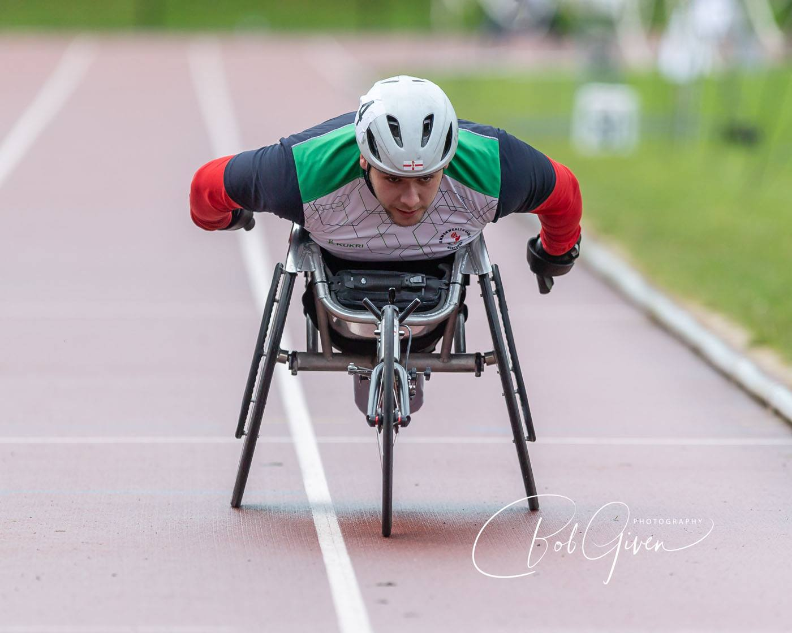
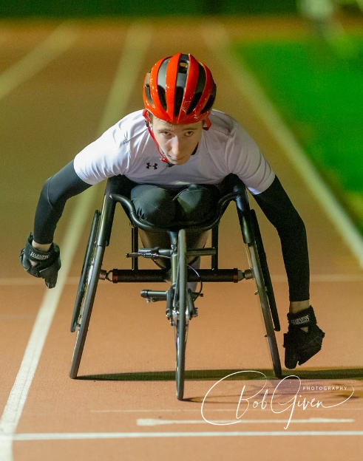
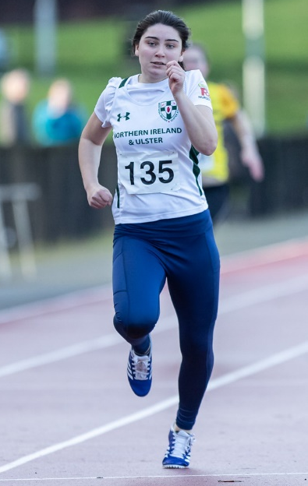
LOOKING BEYOND YOUR ACADEMY EXPERIENCE

The aim of our academies is to enhance the sporting knowledge, physical and psychological skills and performance behaviours of athletes to better equip them to undertake senior training with their personal coach in future.

“The academies are not designed to provide ongoing facilities access, strength and conditioning or physiotherapy support through an athlete’s senior career but instead to equip athletes and coaches with the skills they need to maximize their use of these services elsewhere as a pair.”

Youth Academy staff will support athlete transitions for those leaving Northern Ireland for university. Staff will also support other Academy exits by meeting with athlete-coach pairs to discuss next steps and areas for progress. We will help you identify what level of performance will be required for inclusion on the Commonwealth Potential Programme and discuss how athletes can best tap into the support personal coaches, clubs and universities offer.

“Inevitably not all Youth Academy Athletes will make the Commonwealth Potential Programme but the Academy systems are designed to create upward pressure on the pathway and increase the number who do. By raising the potential of athlete-coach pairs we will increase the probability that talented juniors will progress to a Major Championships whilst also increasing the quality of national level athletes for Northern Ireland teams.”

- Ben Fisher - moved to Loughborough University (2017) aged 18 and was included on the Commonwealth Potential Programme at the age of 19 after jumping a PB.
- Callum Crawford Walker - Moved to St Mary’s University (2017) and lowered his 800m PB to 1:49.88 in 2020.
- Lauren Roy - remains in N.I and was supported by the Commonwealth Potential Programme from the ages of 19-21 after selection for European Indoors 2019.
- Ellen McCartney - moved initially to Brunel University (2018) and after raising her PB from 3.90m to 4.01 in 2019 was included on the Commonwealth Potential Programme at the age of 20 in 2020.
- Megan Marrs - moved to Loughborough University (2016) and achieved the Commonwealth Standard at the age of 23 having been supported by the Commonwealth Potential Programme since the age of 20.
- Kate O’Connor - remains in Ireland and was first supported by the Commonwealth Potential Programme at the age of 18 having competed in the Commonwealth Games aged 17 (2018). Kate has been supported by the Olympic Potential programme since 2019 after winning a European Junior Silver Medal.
STAFF
- Laura Kerr is the Talent Lead for Athletics NI and will drive the vision for talent. Laura will shape the curriculum delivered in the academies and liaise with British Athletics and Athletics Ireland to oversee the progress of NI’s Junior Athletes. Laura will also work closely with funders and the Athletics NI Management Team to ensure talent programmes evolve year on year with effective resourcing.

- Amy Foster will take up the role of Academies Manager in October 2021 and will have day to responsibility for delivery of Academy sessions and effective communication with athletes, coaches, staff, sponsors and facility providers. Amy will oversee athlete tracking and monitoring.

- Tom Reynolds is the Performance Lead for Athletics NI and will oversee competition policies, selections, individual athlete planning and transitions to the Commonwealth Potential Programme.

- Pathways Coaches & Physiotherapists will support the delivery of weekly Strength & Conditioning, Speed Development and Injury Prevention Clinics. These individuals will be announced at the Academy launch.

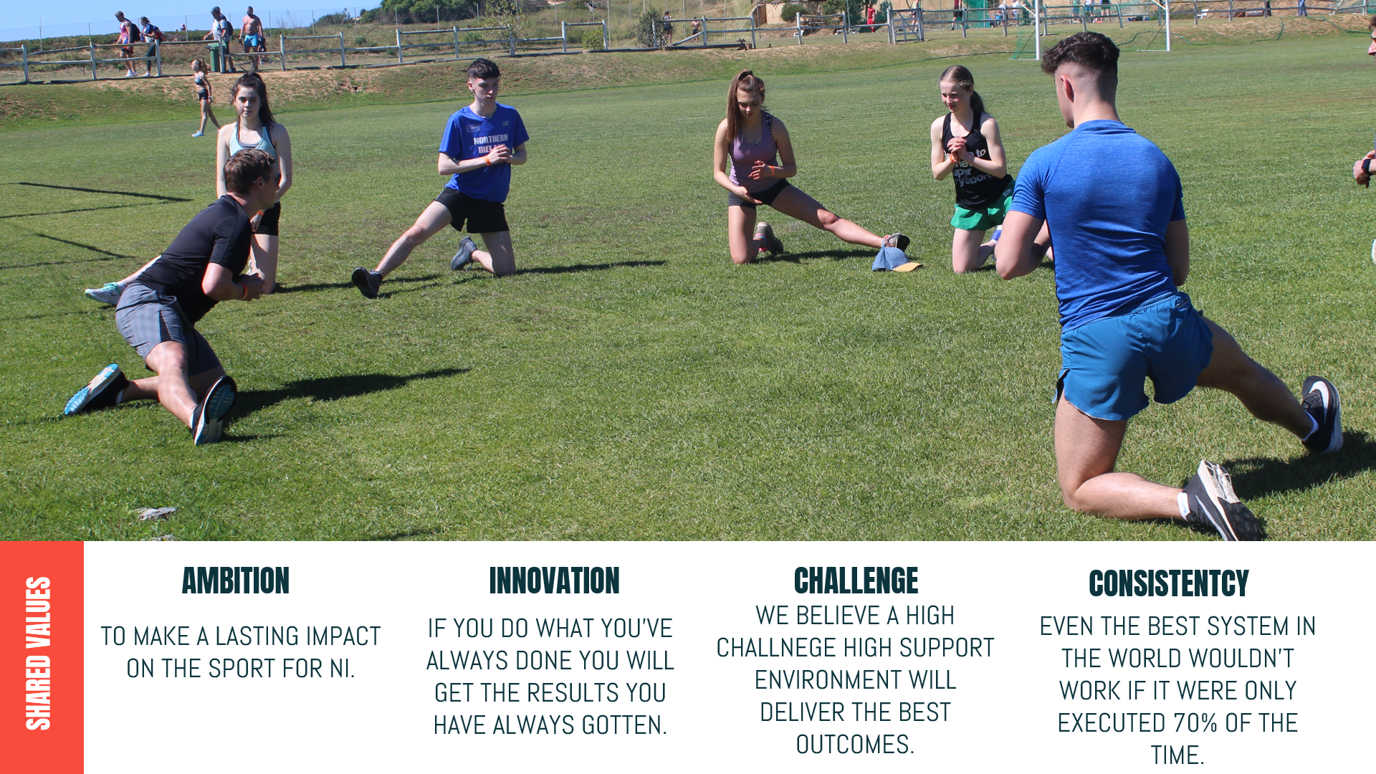
WEEKLY AND ANNUAL DELIVERY

Weekly academy sessions will run for a minimum of 30 weeks this year with some closures for Christmas and Easter. There will be an end of season break in late August/ September. There is likely to be disruption to service provision during July-August when some staff will travel with the Northern Ireland Team to the Commonwealth Games and associated holding camp. The Commonwealth Games are the competitive pinnacle for many athletes and coaches representing Northern Ireland and we hope Academy members would be understanding of disruptions at this crucial time.

WEEKLY DELIVERY

YOUTH ACADEMY BASED AT JORDANSTOWN

MONDAYS- A small group of academy athletes will be able to attend on a Monday evening between 5-7pm for Speed Development and Strength and Conditioning.
TUESDAYS- Speed development, S&C and Physiotherapy clinics will be delivered between 6-9pm with athletes typically attending for 2 hours minimum. This is the primary youth academy session that the majority of athletes will need to attend.
FRIDAYS- Speed Development and S&C will be delivered between 4.30-6.30pm. This may be the the primary session for some Academy Athletes who cannot attend on a Tuesday or a secondary session for others.

YOUTH ACADEMY BASED AT COLERAINE

WEDNESDAYS- Speed Development and S&C will be delivered between 5-8pm with groups staggered so that each athlete attends for 2 hours. Athlete Education sessions will also take place on occasional Wednesday nights.

**Athletes may apply to join the Youth Academy even if they are not available to attend weekly sessions however they must demonstrate clear rationale and willingness to engage with athlete, coach and parent education sessions and injury prevention elements of the programme. Programming for remote S&C may be requested if clear need is demonstrated.

SPEED POWER ACADEMY BASED AT ULSTER UNIVERSITY, JORDANSTOWN

FRIDAYS- Speed Development and S&C will be delivered between 5.30-7.30pm. There will be occasional education workshops delivered on Friday evenings at UUJ or on Zoom. Athletes should not apply for this Academy if they cannot attend at these times as there are no other options.

YOUTH ACADEMY CAMPS
- HALLOWEEN LAUNCH DAY – SATURDAY 30TH OCTOBER 2021

- FEBRURAY HALF TERM GET TOGETHER – SATURDAY 19TH FEBRUARY 2022

WARM WEATHER TRAINING

- HALLOWEEN 2021- Tentative plans for an endurance/road/cross country focused camp in Portugal dependant on Covid 19 restrictions and foreign office advice. Subject to approval from our funders Erasmus+.

- EASTER 2022- Tentative plans for a Track and Field focused pre-season camp in Portugal dependant on Covid-19 restrictions and foreign office advice. Subject to approval from our funders Erasmus+.

FEES
For successful applicants the athlete fees for inclusion in the Academies October 2021- August 2022 will be as follows.

 | 2021-2022 FEE | NOTES
YOUTH ACADEMY JORDANSTOWN | £250 | This fee includes weekly S&C, Speed Development Sessions, access to physiotherapy clinics at UUJ, screening at the Halloween Launch Day and Half Term Camp. Athletes who do not plan to attend weekly but wish to access educational and camp elements or remote S&C programming and strength diagnostics can contact amy@athleticsni.org to discuss the possibility of a fee reduction.
ACADEMY HUB | £150 | The annual fee is £150 after subsidy from British Athletics
YOUTH ACADEMY COLERAINE | £150 | The reduced price at YA Coleraine compared to UUJ is due to fewer weekly training options being available at Coleraine. The high cost of indoor track use at Jordanstown also increases the cost there.
SPEED POWER ACADEMY JORDANSTOWN | £220 | This includes weekly S&C and speed development including movement screening, strength diagnostics, coach feedback and 3 educational workshops.

Electronic payment will be requested when weekly delivery commences.

APPLICATION & SELECTION

The academies aim to support athletes and coaches who have identified their own strengths, weaknesses and areas for progress over the next 3-5 years and who will benefit most from engaging with the physical preparation, physiotherapy and performance lifestyle support available. Selection will prioritise athletes who demonstrate the potential and ability to eventually represent Northern Ireland at a Senior Commonwealth Games.

Selection Criteria
There are no specific entry standards for Academy Selection as limited Academy capacity means athletes across all events must be compared.

Athletes will be assessed for inclusion based upon their performance standards and performance potential.

Performance

- Track and Field performances (which should be accurately reported in the Excel application form) will be assessed by comparison to European Athletics Minimum Championship Standards for European U18, U20 and U23 Championships. Consideration for road, cross country and mountain running performances will be made.

- Performance levels will also be compared to Power of 10 Rankings and Power of 10 Top 10 Targets. These Power of 10 targets will be especially useful in considering U16 athletes who cannot be compared to European Athletics U18 standards.

Potential

- Potential for senior success will also be considered. Coaching partnership, commitment to the sport, maturation, peaking age for event, demonstration of ability and mindset to access support available will all be considered. The selection panel will discuss:

    - Coaching relationship and training environment
    - Training history
    - Training gaps
    - Motivation
    - Commitment to athletics and balance with other sports
    - Coach engagement
    - Injury history
    - Availability and mindset to engage with the programme for maximum impact
The selection panel will also discuss maturation, peaking ages in different event groups and impact on performance trajectory.

SELECTION PROCESS

- Athletes who apply will be compared to each other based on performance, potential and ability to engage with the programme.

- Athletes will then be ranked in priority order for selection to the academies.

- Athletes will be offered places in Academies based on total capacity.

RETENTION

Each athlete will be evaluated after 1 year in the Academy and invited to reapply demonstrating their progress and ongoing commitment to athletics. Ideally athletes who are progressing their performances would remain in the Academy for 3-4-years before transitioning to either a university system or onto the Athletics NI Commonwealth Potential Programme. The Academy programme is designed with the aim of delivering the curriculum over three years.

APPLICATION

Athlete -Coach pairs should meet to complete the excel form and return by email to amy.foster@athleticsni.org by 11am on 20th September 2021. The form must be returned electronically and completed using the Excel document provided. No paper copies will be accepted. Those who don’t have Excel on their personal laptop should access it on a school, university or library computer.

Please complete all sections of the Excel form. We recommend that athlete and coach discuss the completion of this form and parents of U18 athletes are closely involved in the application process.

ASSESSMENT OF APPLICATIONS
Factors considered will include:
- Performance levels compared to Power of 10 Rankings, Power of 10 Top 10 Targets, European Athletics Minimum Standards for U18/U20/U23 Championships.
- Potential for progress- coaching partnership, commitment to the sport, maturation, peaking age for event, demonstration of suitable ability and mindset to access support available.

The Academy selection panel will be made up of:
Laura Kerr (Talent Lead)
Tom Reynolds (Performance Lead)
Amy Foster (Academies Manager)
COMPETITIONS IN 2021-22

Major Championships on the horizon for athletes aged 15-22 years old include…

- European Cross Country, Dublin, December 2021
- World University Games, China, June 2022
- European U18 Championships, Israel, July 2022
- Commonwealth Games, Birmingham 2022
- World U20 Championships, Columbia, August 2022
- UK Schools Games (U17) September 2022 (TBC)

A return to normal annual delivery post Covid 19 would also see NI/NI & Ulster Teams fielded at:
- Northern Ireland International XC including Home Countries International, January 2022
- Celtic XC International, January 2022
- UK Intercounties XC, February 2022
- EAP U23 International, Nivelles, Belgium or Valence, France, June 2022
- Welsh U20 International Cardiff, July 2022
- Manchester U20 & Senior International, August 2022

High Performing Individual Athletes who will be competitive in finals are likely to be supported towards:
- England Championships U17, U20 or U23 Championships in Bedford, 2022
- Home Countries Combined Events U15 / U17 / U20, Manchester in August 2022
