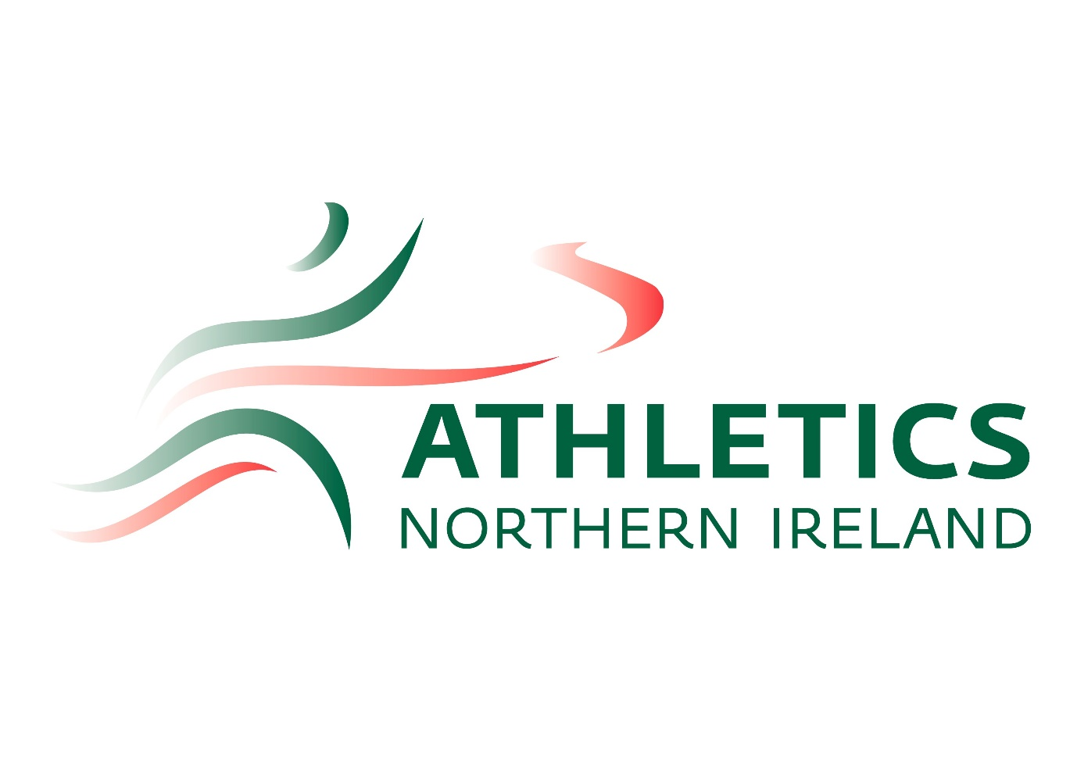

Complaints policy
Updated: 4th March 2023

Version History | Date of Version | Amendments/Notes
VERSION 1.0 | March 2019
VERSION 1.1 | 4th March 2023 | Job roles amended


Athletics Northern Ireland - Complaints Policy
Athletics Northern Ireland understands the importance of excellence in the delivery of its services. We are committed to creating and developing a positive approach to the services we deliver in which we strive to consistently exceed expectations of our stakeholders. We aim to create an environment within which excellence is seen as essential to the management and delivery of services. We are committed to continual improvement. This includes handling complaints carefully in an open and courteous way by investigating the matters raised thoroughly and replying as quickly as possible.
We will treat an individual or organisation making a complaint impartially, in confidence and with respect and courtesy. No individual or organisation will be adversely treated because they have found cause to complain about our service.
We aim to ensure that:
- Making a complaint is as easy as possible
- We treat your complaint seriously
- We deal with your complaint promptly and in confidence
- We learn from complaints and use them to review and improve our service

What is a complaint?
A complaint is when you tell us you are not happy about the service we provide. It can be about anything and could include
- When we do not deliver a service on time
- When we give you the wrong information
- When you receive a poor quality service
- When you have a problem with a member of staff

How to make a complaint
If you wish to make a complaint you can contact the Athletics Office in any of the ways listed below.
By email to Elaine Grant, Chief Executive Officer at ceo@athleticsni.org
In writing to Athletics Northern Ireland at
Athletics House
Old Coach Road,
Belfast
BT9 5PR
By phone to our Administration Team on 028 90602707.
In person at the Athletics Office.
What happens to my complaint? (Stage One)
Once you have made a complaint to Athletics Northern Ireland we will send you an acknowledgement within three working days of receipt. That acknowledgement will provide an indication as to who will be responsible for responding to you and when you can expect to receive a reply. If we cannot investigate your complaint, we will write to you explaining why.
We expect to respond to the majority of complaints within 15 working days of the complaint arriving with us. The time taken to respond will vary depending on the complexity of the complaint. However if we are unable to respond within this deadline because, for example, the matters you raise require more detailed investigation, we will let you know.
We will give serious consideration to the issues you raise. Where we identify mistakes in our approach we will acknowledge those and this may include providing an apology, setting out details of other steps we think are necessary in the circumstances, and explaining what we will do to prevent the problem occurring again.
What happens if I disagree with the outcome, or how my complaint was handled? (Stage Two)
We will make every effort to satisfactorily resolve your complaint in the first instance. However, if you are not satisfied by our response or by the way that your complaint was handled, you should appeal to the Chairman (David Abrahams). You will need to outline why you are dissatisfied with the initial response.
We will acknowledge the appeal within three working days of receipt and the Chair will arrange for the case to be reconsidered by a member of staff who was not previously involved in handling your complaint. This stage will involve a full independent review of the handling of your complaint and all associated papers. The outcome of this appeal, which will be final and binding on both parties, will be communicated to you in writing within 15 working days of the receipt of the appeal. However if for any reason there is a problem with collating the response, we will inform you of the reason for a delayed response and will inform you of the expected date of reply. After this outcome no further action or referrals will be entertained on the issue.
All parties must treat any complaint in a completely confidential manner.

