COMMONWEALTH AND OLYMPIC/PARALYMPIC POTENTIAL PROGRAMMES - BACKGROUND
& APPLICATION PACK
2022

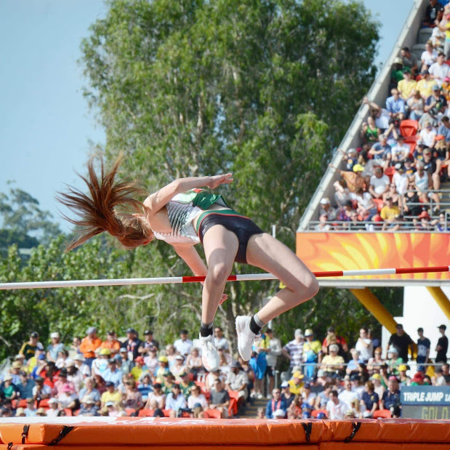
ASPIRING TO EXCELLENCE

Vision

We aim to raise the profile of athletics in Northern Ireland by facilitating more of our athletes and their coaches to be competitive on the world stage and so inspire the entire population.

Athletics Northern Ireland's Performance Programmes include Commonwealth Potential and Olympic/Paralympic Potential (formerly Podium Potential) squads. The aim of the squad system is to support Northern Ireland’s best athletes towards Commonwealth and Olympic/Paralympic success with support for sports science & medicine plus competition & training opportunities at appropriate levels and in appropriate environments.

In October 2017, Athletics NI launched the Commonwealth and Podium Potential Programmes. We know that access to integrated services and overseas camps and competitions are critical to an athlete’s preparation for major championships along with the confidence that brings that they and their coaches are supported to work on the determinants for success.

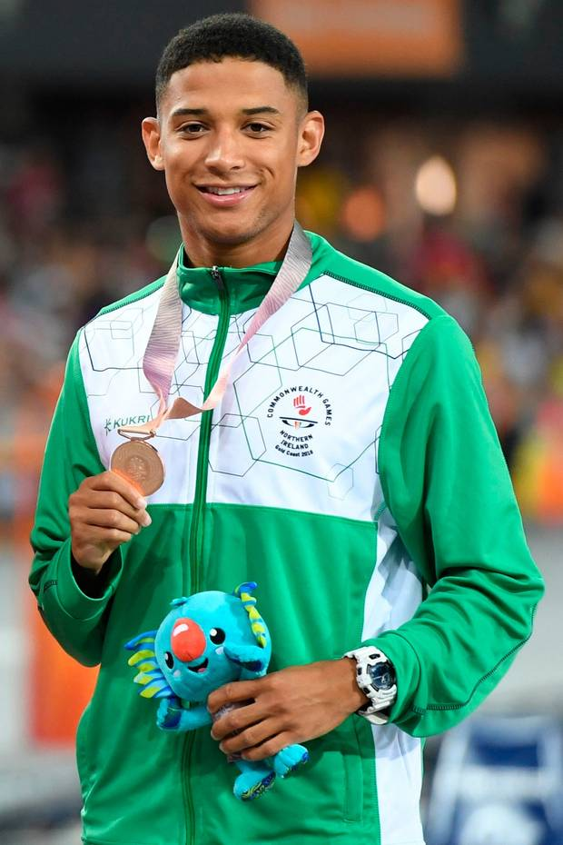
The Athletics Northern Ireland Commonwealth and Podium Potential Programmes have supported approximately 35 of the country’s top athletes through a periodised programme that includes centralised warm weather and altitude training camps at critical times of the year, sports science & medicine through the Sport Northern Ireland Sports Institutes or other experts if the athlete is not based in Northern Ireland and individual support for competition programmes. In addition, we have supported coaches with their professional development and to travel with their athletes to camps and competitions.

Since then, we have celebrated our best Commonwealth Games since 1990 and second best ever in terms of winning a medal and achieving the most top 8 positions (5). We had a record equalling six NI athletes compete in Tokyo Olympics and two at the Paralympics. Furthermore, we have seen no less than 28 senior and junior Northern Ireland records broken since 2017 and witnessed more Northern Ireland athletes performing at World and European level.

Building upon these successes Athletics NI will relaunch these programmes for 2022.

Northern Ireland’s success in the 2017 – 2021 cycle:

In addition to 28 new Northern Ireland records Athletics Northern Ireland have supported athletes in the Commonwealth and Podium Potential Programmes to major championship representation and success.

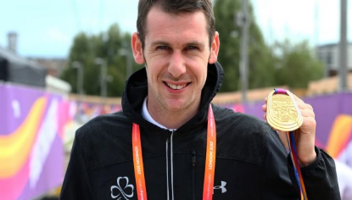
Four golds and two top eights at the 2017 World Paralympic Championships (Jason Smyth – T13 gold in the 100m and 200m, Michael McKillop T37 gold in the 800m and 1500m, James Hamilton – T20 6th in the 800m and 1500m). Jason Smyth also claimed double gold at the 2018 European Paralympic Championships.
.

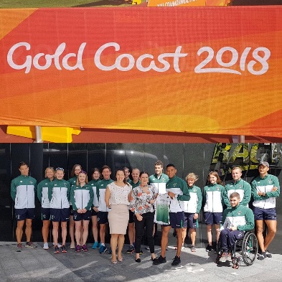

One bronze medal and five top eights at the 2018 Commonwealth Games (Leon Reid – 200m bronze medal; Kevin Seaward – marathon 4th, Dempsey McGuigan – Hammer 6th, Kate O’Connor – Heptathlon 8th, Adam Kirk-Smith – Steeplechase – 8th)

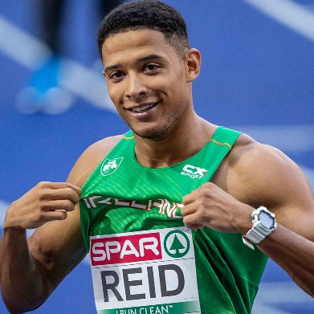
Eleven Northern Ireland athletes at the 2018 European Championships (Ciara Mageean – 1500m 4th, Leon Reid – 200m 7th and relay 5th, Davicia Patterson – Relay 8th, Adam McMullen – Long Jump 13th, Kevin Seaward – Marathon 15th, Emma Mitchell – 10,000m 15th, Kerry O’Flaherty – 3000m Steeplechase 17th, Stephen Scullion – 10,000m 23rd, Breege Connolly – Marathon 31st, Gladys Ganiel – Marathon 33rd, Paul Pollock – Marathon 47th)

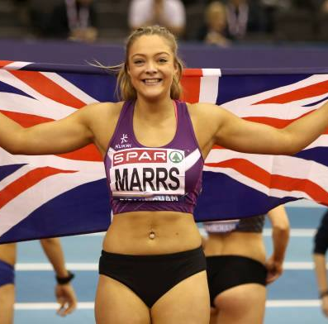
Megan Marrs was the British Indoor 60m Hurdles Champion and represented GB at the 2018 World Indoor Championships in Birmingham (8.16s)

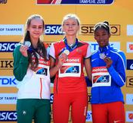
World Junior Silver in the High Jump (1.90m) for Sommer Lecky in 2018

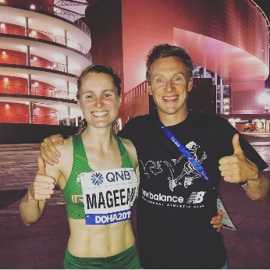
Ciara Mageean – 2019 European Indoors 1500m bronze medallist, 10th at the World Athletics Championships in 2019 in the fastest ever women’s 1500m race with a new Northern Ireland record of 4:00.15. Ciara has also claimed the NI 3000m indoor record and 800m outdoor record

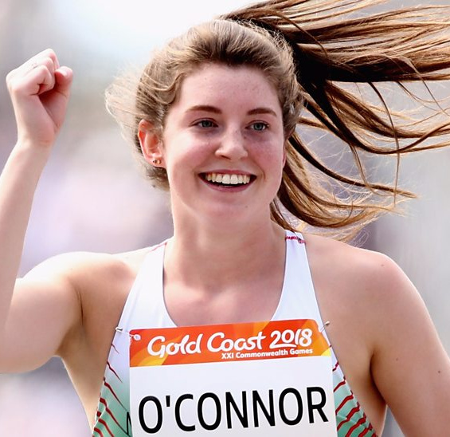
Kate O’Connor- European U20 Silver in 2019 (6093 points) and Top 8 finishes at European Youth Championships Heptathlon (Georgia 2016), European Junior Championships 2017 (Italy) and Commonwealth Games 2018 (Australia) with Northern Ireland senior records in javelin and heptathlon.

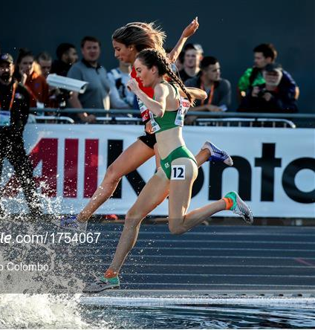
Six NI athletes competed in the Tokyo Olympics which is the equal highest number recorded. Leon Reid (200m), Eilish Flanagan (3000m SC) and Ciara Mageean (1500m) all recorded top 32 positions.

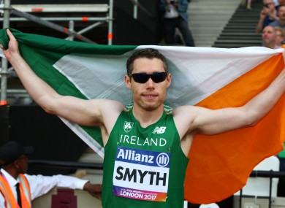
At the World Paralympic Championships in 2019 Jason Smyth won gold in the T13 100m in a Championship record of 10.54. Michael McKillop finished 4thin the T37/T38 1500m with David Leavy 9th in the same event. Conor McIlveen finished 7th in the T38 400m
Jason Smyth retained his Paralympic title in Tokyo with a dramatic photo finish while multiple gold medallist Michael McKillop placed 8th in his final championship race having medalled at the European Championships earlier in 2021.

COMMONWEALTH AND OLYMPIC/PARALYMPIC POTENTIAL STRUCTURE FOR 2022

For 2022 athletes eligible to represent Northern Ireland at the Commonwealth Games (event allowing) may apply for support and inclusion in one of two programmes:

Commonwealth Potential
Olympic and Paralympic Potential

Both programmes are funded by the Sport NI Sporting Winners investment.

Commonwealth Potential Programme

Athletics NI will support coach-athlete pairs with the aim of progressing athletes to achieve medals and top eight places at the Commonwealth Games and gaining selection onto the UKA Futures Programme or the Irish Carding System.
This programme is structured to support athletes towards the Birmingham Games in 2022 with regular physiotherapy support and regular training camps.
Olympic Potential Programme

The target of the Olympic/Paralympic Potential Programme is to support athlete development to achieve medals and top sixteen places at the Olympic and Paralympic Games and World Championships and gain selection onto the UKA World Class Performance Programme or the Irish Carding System. Olympic/Paralympic Potential athlete and coach pairs are eligible for Sporting Winners investment that includes support from the Sport Northern Ireland Sports Institute (SNISI). This may include technical support, strength and conditioning, physiotherapy, competition expenses, training camps, equipment, sports science and sports medicine. Where there is a need and the athlete is eligible, they may also be put forward for the Sport NI Athlete Award that provides support for living costs.

To be successful in their applications athletes and coaches will need to demonstrate how the support and services on offer will progress their athletic development to achieve Commonwealth and/or Olympic/Paralympic standards. Athletes will be assessed for inclusion based upon their performance standards and performance potential.

Eligibility & Availability

For 2022 athletes eligible to compete for Northern Ireland at the 2022 Commonwealth Games (event allowing) may apply for inclusion in the Commonwealth Potential or Olympic/Podium, Potential Programmes.

APPLICATION & SELECTION

The performance programmes aim to support athletes and coaches who have identified their own strengths, weakness and areas for progress over the next 1-5 years and who will benefit most from engaging with the support available.

Selection Criteria

Performance
Performances reported in the form below will be assessed by comparison to Commonwealth Games, Olympic Games and Paralympic Games standards

Potential
A panel of experts led by the Performance Lead will discuss each athletes' performance potential based upon information provided in the application form relating to:

- Training age
- Coaching relationship and environment
- Training history
- Training gap analysis
- Motivation
- Commitment to help Athletics NI achieve Sporting Winners targets
- Availability to engage with the programme for maximum impact
- Coach engagement
- Injury history

The selection panel will also be aware of and discuss maturation and peaking ages in different event groups.

Selection Process
- Athletes who apply will be assessed on a case-by-case basis considering performance standards, potential to progress and the likely impact of engagement with the programme on the ability of an athlete to finish top 8 at the Commonwealth Games.
- Athletes will then be ranked in priority order for selection to the programmes.

Retention
Post summer 2022 athletes will be invited to reapply demonstrating their progress and ongoing commitment to the targets.

APPLICATION

Athlete -Coach pairs should meet to complete the form below and return by email to luke.dinsmore@athleticsni.org by 7th January 2022 but applications will be assessed as soon as possible after they come in. Questions can be emailed to tom.reynolds@athleticsni.org

To apply for Athletics NI programme support for 2022 please answer all questions below and tick all applicable boxes. We recommend that athlete and coach meet to complete this form along with anyone else closely involved in the application process.

Please tick one or more boxes to complete this statement. If you tick more than one box the selection panel will use the information you provide later to determine the best programme for you

I wish to be considered for…

Commonwealth Potential
Olympic/Paralympic Potential

My Profile

Age:
DOB:
Coach:
Home Town:
Normal Training Location:

Main event | Secondary Event
2018 PB: date; | 2018 PB: date;
2019 PB: date; | 2019 PB: date;
2020 PB: date; | 2020 PB: date;
2021 PB | 2021 PB

Please highlight the Championship you are aiming for: Commonwealth Games 2022/World Championships 2022/European Championships 2022

Please name the event and the qualifying standard that you are aiming for:_________________________________

Please provide a details of your training (including environment), performance lifestyle and any injury prevention/rehabilitation that you have worked on. Please highlight any previous areas of engagement with Athletics NI that have supported your improvements and a move towards standards.

Athlete-Coach Relationship/Partnership
Please comment on the areas that work well in your relationship and any areas that need to be addressed.
Physical Preparation

Please comment on the effectiveness of your S & C programme/physiological interventions/prehabilitaton training etc.

Technical Preparation

Please assess your technical ability in relation to the world class technical model for your event. Please also note any biomechanical issues.

Tactics

Please comment on your tactical ability in competition performance
Performance Psychology

Please comment on your ability to perform under pressure.
Competition Planning
How would you normally plan your competition season?
Sports Medicine

How effective was your use of physiotherapy, prehab, soft tissue, blood diagnosics etc.
Nutrition

Please assess the effect of your nutritional habits on performance
Performance Lifestyle Planning

Assess how your non-training time contributes to your performance. Please comment on sleep, recovery, effective use of funding, how your employment or education status supports your training

Coach Development

Please list any training, mentoring or experience that has been identified to fill gaps in coaching knowledge, skill and behaviour or to take you to the next level.
Additional areas for comment

Please explain your areas of focus for 2021and 2022 and any risk or limiting factors that you need to address

2022 Season Plans
Please explain which major championships you are focussing on for 2022 and in what priority order. For each championship please identify how you expect to qualify (e.g. gaining standard of …. And demonstrating consistent top 8 potential OR making the ranking quota of ….. by posting 5 performances averaging ….. IAAF points)

Priority Championship 1 –

Priority Championship 2 –

Priority Championship 3 –

If one of your priority championships is the Commonwealth Games please indicate how you hit the criteria of having competed in a NI Championships Event in 2021-2022. If you have not already done this, please outline which of the following events you will target to make yourself eligible for nomination to the CGNI.
I competed in the 2021 NI & Ulster Championship event of….

or

I will be targeting the following championship event…

- Senior XC Championships 26 February 2022
- Queens 5k Championships 6 April 2022
- Belfast International 28 May 2022 (As NI & Ulster T&F is now outside the nomination window after 5 June)
(NB If targeting this meeting please list event requested so we can ensure it is in the programme)

Centralised training camps 2022 – Current likely centralised camp options are January (Portugal, Spain or Tenerife), April / May (Portugal or Florida). CWG holding camp is already booked 12-27 July in Slovakia.
Please let us know your preference of location and dates for camps, it is still possible for budget to be allocated to self organised camps outside of those above.
Please let us know what essential support is required from Athletics NI to ensure your plan can be carried out. Please specify athlete and coach requirements, that cannot otherwise be found, along with estimate of cost.

Please outline funding you receive from other organisations eg Athletics Ireland/British Athletics/Sport NI Athlete Award
Please complete the paragraphs below
Athlete statement:
My short-term goal is –
My long-term goal is –
Inclusion in the programme will benefit me because -

Coach statement:
To bridge the gap to Olympic/Paralympic/Commonwealth standard, I feel the athletes needs to –
The most beneficial aspects of the programme for this athlete will be –
My own areas for development as a coach are -

After review of applications received by 7th January 2022 there will be a selection process and successful applicants will be contacted and made an offer of support for 2022.

Applications may be typed or handwritten and then scanned but must be emailed to luke.dinsmore@athleticsni.org by 7th January 2022

Athletics NI intend to communicate with all applicants within two weeks of receiving the application

