COMMONWEALTH AND OLYMPIC/PARALYMPIC POTENTIAL PROGRAMMES - BACKGROUND
& APPLICATION PACK
2021
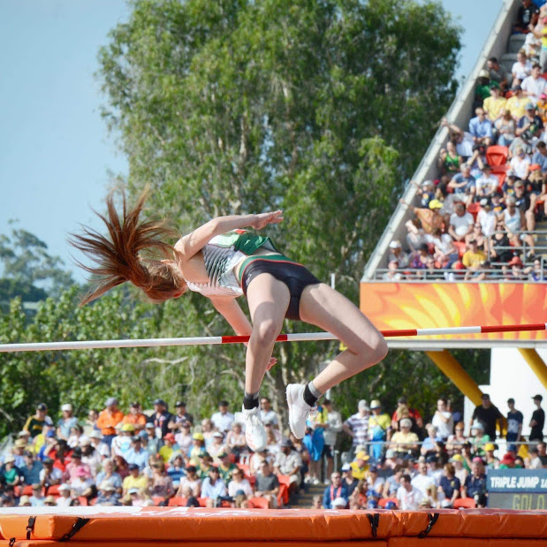
ASPIRING TO EXCELLENCE

Vision

We aim to raise the profile of athletics in Northern Ireland by facilitating more of our athletes and their coaches to be competitive on the world stage and so inspire the entire population.

Athletics Northern Ireland's Performance Programmes include Commonwealth Potential and Olympic/Paralympic Potential (formerly Podium Potential) squads. The aim of the squad system is to support Northern Ireland’s best athletes towards Commonwealth and Olympic/Paralympic success with support for sports science & medicine plus competition & training opportunities at appropriate levels and in appropriate environments.

In October 2017, Athletics NI launched the Commonwealth and Podium Potential Programmes. We know that access to integrated services and overseas camps and competitions are critical to an athlete’s preparation for major championships along with the confidence that brings that they and their coaches are supported to work on the determinants for success.

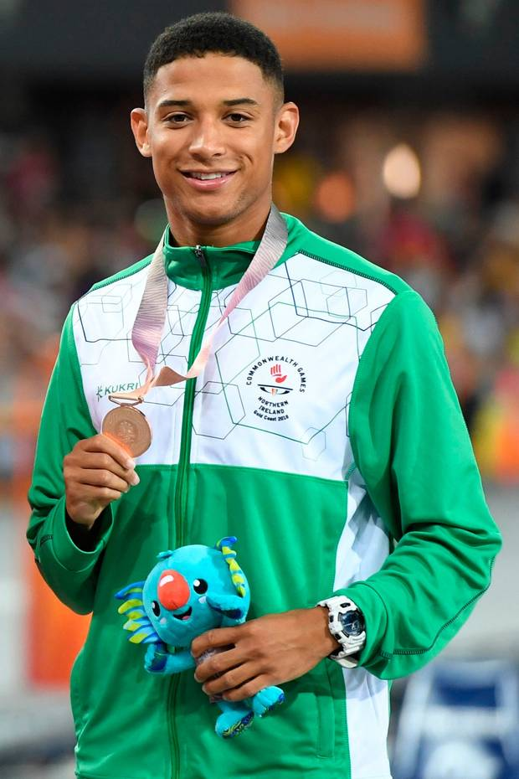
The Athletics Northern Ireland Commonwealth and Podium Potential Programmes have supported approximately 35 of the country’s top athletes through a periodised programme that includes centralised warm weather and altitude training camps at critical times of the year, sports science & medicine through the Sport Northern Ireland Sports Institutes or other experts if the athlete is not based in Northern Ireland and individual support for competition programmes. In addition, we have supported coaches with their professional development and to travel with their athletes to camps and competitions.

Since then we have celebrated our best Commonwealth Games since 1990 and second best ever in terms of winning a medal and achieving the most top 8 positions (5). Furthermore, we have seen no less than 28 senior and junior Northern Ireland records broken since 2017 and witnessed more Northern Ireland athletes performing at World and European level.

Building upon these successes Athletics NI will relaunch these programmes for 2021, with Podium Potential renamed as Olympic Potential to accurately reflect the mission that each of them will drive.

Northern Ireland’s success in the 2017 – 2021 cycle:

In addition to 28 new Northern Ireland records, Athletics Northern Ireland have supported athletes in the Commonwealth and Podium Potential Programmes to major championship representation and success.

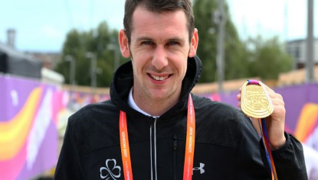
Four golds and two top eights at the 2017 World Paralympic Championships (Jason Smyth – T13 gold in the 100m and 200m, Michael McKillop T37 gold in the 800m and 1500m, James Hamilton – T20 6th in the 800m and 1500m). Jason Smyth also claimed double gold at the 2018 European Paralympic Championships.
.

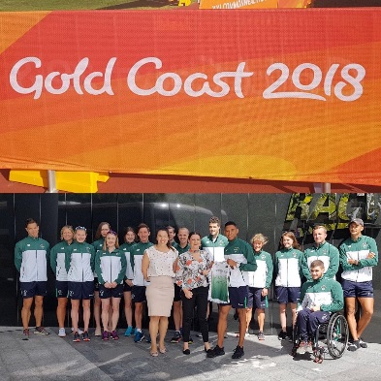

One bronze medal and five top eights at the 2018 Commonwealth Games (Leon Reid – 200m bronze medal; Kevin Seaward – marathon 4th, Dempsey McGuigan – Hammer 6th, Kate O’Connor – Heptathlon 8th, Adam Kirk-Smith – Steeplechase – 8th)

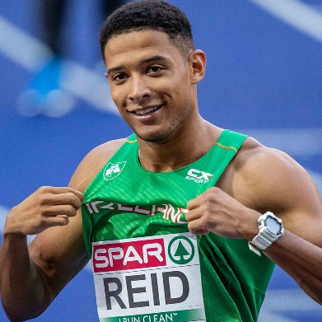
Eleven Northern Ireland athletes at the 2018 European Championships (Ciara Mageean – 1500m 4th, Leon Reid – 200m 7th and relay 5th, Davicia Patterson – Relay 8th, Adam McMullen – Long Jump 13th, Kevin Seaward – Marathon 15th, Emma Mitchell – 10,000m 15th, Kerry O’Flaherty – 3000m Steeplechase 17th, Stephen Scullion – 10,000m 23rd, Breege Connolly – Marathon 31st, Gladys Ganiel – Marathon 33rd, Paul Pollock – Marathon 47th)

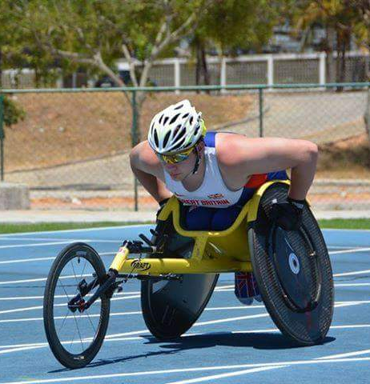

Three Golds at World Junior Para Championships in 2017 (Jack Agnew- T54 800m 1:42:04/ 1500m 3:07:05 & Eve Walsh-Dann T38 - 100m 14.54)

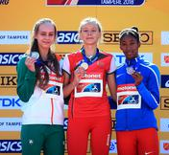
World Junior Silver in the High Jump (1.90m) for Sommer Lecky in 2018

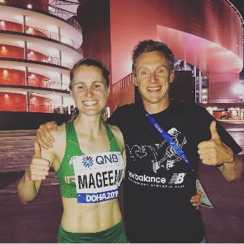
Ciara Mageean – 2019 European Indoors 1500m bronze medallist, 10th at the World Athletics Championships in 2019 in the fastest ever women’s 1500m race with a new Northern Ireland record of 4:00.15. Ciara has also claimed the NI 3000m indoor record and 800m outdoor record

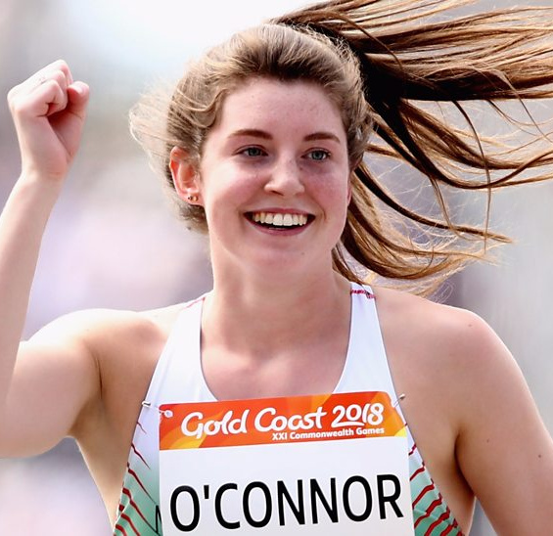
Kate O’Connor- European U20 Silver in 2019 (6093 points) and Top 8 finishes at European Youth Championships Heptathlon (Georgia 2016), European Junior Championships 2017 (Italy) and Commonwealth Games 2018 (Australia) with Northern Ireland senior records in javelin and heptathlon.

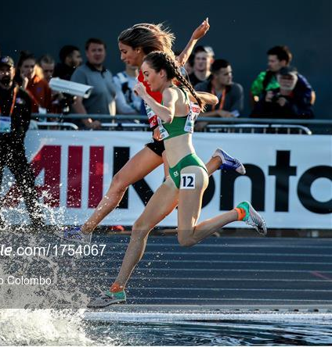
Eilish Flanagan - European U23 Silver in 2019, silver team medal at European Cross-Country Championships and silver medal at the NCAA Div II Cross Country Championships. Roisin Flanagan was also part of the silver medal winning team at the European Cross-Country Championships and won individual bronze at the NCAA Div II Cross Country Championships. Roisin has also claimed the NI 5000m record.

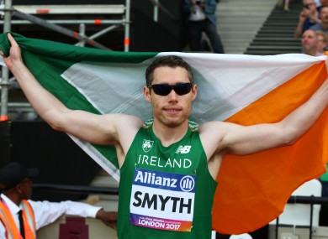
At the World Paralympic Championships in 2019 Jason Smyth won gold in the T13 100m in a Championship record of 10.54. Michael McKillop finished 4thin the T37/T38 1500m with David Leavy 9th in the same event.

COMMONWEALTH AND OLYMPIC/PARALYMPIC POTENTIAL STRUCTURE FOR 2021

For 2021 athletes eligible to represent Northern Ireland at the Commonwealth Games (event allowing) may apply for support and inclusion in one of two programmes:

Commonwealth Potential
Olympic and Paralympic Potential

Both programmes are funded by the Sport NI Sporting Winners investment.

Commonwealth Potential Programme

Athletics NI will support coach-athlete pairs with the aim of progressing athletes to achieve medals and top eight places at the Commonwealth Games and gaining selection onto the UKA Futures Programme or the Irish Carding System.
This programme is structured to support athletes towards the Birmingham Games in 2022 with regular physiotherapy support and regular training camps.
Olympic Potential Programme

The target of the Olympic/Paralympic Potential Programme is to support athlete development to achieve medals, top 32 places, qualification for the Olympic and Paralympic Games and World Championships and gain selection onto the UKA World Class Performance Programme or the Irish Carding System. Olympic/Paralympic Potential athlete and coach pairs are eligible for Sporting Winners investment that includes support from the Sport Northern Ireland Sports Institute (SNISI). This may include technical support, strength and conditioning, physiotherapy, competition expenses, training camps, equipment, sports science and sports medicine. Where there is a need and the athlete is eligible, they may also be put forward for the Sport NI Athlete Award that provides support for living costs.

To be successful in their applications athletes and coaches will need to demonstrate how the support and services on offer will progress their athletic development to achieve Commonwealth and/or Olympic/Paralympic standards. Athletes will be assessed for inclusion based upon their performance standards and performance potential.

Eligibility & Availability

For 2021 athletes eligible to compete for Northern Ireland at the 2022 Commonwealth Games (event allowing) may apply for inclusion in the Commonwealth Potential or Olympic/Podium, Potential Programmes.

APPLICATION & SELECTION

The performance programmes aim to support athletes and coaches who have identified their own strengths, weakness and areas for progress over the next 1-5 years and who will benefit most from engaging with the support available.

Selection Criteria

Performance
Performances reported in the form below will be assessed by comparison to Commonwealth Games, Olympic Games and Paralympic Games standards

Potential
A panel of experts led by the Director of Athletics will discuss each athletes' performance potential based upon information provided in the application form relating to:

- Training age
- Training history
- Training gap analysis
- Performance trajectory
- Coaching relationship and environment
- Commitment to achieving excellence
- Commitment to help Athletics NI achieve Sporting Winners targets
- Availability to engage with the programme for maximum impact
- Coach engagement
- Injury history

In addition to information on performance trajectories, the selection panel will also be aware of and discuss maturation and peaking ages in different event groups.

Selection Process
- Athletes who apply will be compared to each other based on performance standards, potential to progress and the likely impact of engagement with the programme.
- Athletes will then be ranked in priority order for selection to the programmes.

Retention
Each athlete will be evaluated after one year in the programme and invited to reapply demonstrating their progress and ongoing commitment to the targets.

Automatic Selection

Athletes who have already achieved the qualification standard for Tokyo or who have already submitted a plan that demonstrates how they will achieve the standard by performance or maximising ranking points have been automatically included into the Olympic/Paralympic Programme. These athletes and their coaches are:

Jason Smyth
Michael McKillop Paddy McKillop
Ciara Mageean Steve Vernon
Leon Reid James Hillier
Stephen Scullion Robert Denmead
Paul Pollock Andy Hobdell
Kevin Seaward Andy Hobdell
Ann Marie McGlynn Colin Roberts

APPLICATION

Athlete -Coach pairs should meet to complete the form below and return by email to info@athleticsni.org by 4th January at 6pm. Questions can be emailed to jackie.newton@athleticsni.org or tom.reynolds@athleticsni.org

To apply for Athletics NI programme support for 2021 please answer all questions below and tick all applicable boxes. We recommend that athlete and coach meet to complete this form along with anyone else closely involved in the application process.

Please tick one or more boxes to complete this statement. If you tick more than one box the selection panel will use the information you provide later to determine the best programme for you

I wish to be considered for…

Commonwealth Potential
Olympic/Paralympic Potential

My Profile

Age:
DOB:
Contact email:
Contact telephone:
Coach:
Coach contact:
Hometown:
Normal Training Location:

Main event | Secondary Event
2017 PB: date; | 2017 PB: date;
2018 PB: date; | 2018 PB: date;
2019 PB: date; | 2019 PB: date;
2020 PB | 2020 PB

If you are a Para athlete, are you classified? Y/N
If Yes, state your classification ____________

Please highlight the Championship you are aiming for: Commonwealth Games 2022/Olympic Games 2021/Paralympic Games 2021

Please name the event and the qualifying standard that you are aiming for:_________________________________

Please provide a detail of your training (including environment), performance lifestyle and any injury prevention/rehabilitation that you have worked on. Please highlight any previous areas of engagement with Athletics NI that have supported your improvements and a move towards standards.

Athlete-Coach Relationship/Partnership
Please comment on the areas that work well in your relationship and any areas that need to be addressed.
Physical Preparation

Please comment on the effectiveness of your S & C programme/physiological interventions/prehabilitaton training etc.
Technical Preparation

Please assess your technical ability in relation to the world class technical model for your event. Please also note any biomechanical issues.

Tactics
Please comment on your tactical ability in competition performance
Performance Psychology
Please comment on your ability to perform under pressure.
Competition Planning
How would you normally plan your competition season?
Sports Medicine
How effective was your use of physiotherapy, prehab, soft tissue, blood diagnostics etc.
Nutrition
Please assess the effect of your nutritional habits on performance
Performance Lifestyle Planning
Assess how your non-training time contributes to your performance. Please comment on sleep, recovery, effective use of funding, how your employment or education status supports your training

Coach Development
Please list any training, mentoring or experience that has been identified to fill gaps in coaching knowledge, skill and behaviour or to take you to the next level.
Additional areas for comment

Please explain your areas of focus for 2021and 2022 and any risk or limiting factors that you need to address

Please explain how you expect to be selected or qualify for the Olympics, Paralympics or Commonwealth Games by achieving the standard or by targeting competitions and maximising bonus points.

Please outline funding you receive from other organisations eg Athletics Ireland/British Athletics/Sport NI Athlete Award
Please complete the paragraphs below
Athlete statement:

My short-term goal is –

My long-term goal is –

Inclusion in the programme will benefit me because -

Coach statement:
To bridge the gap to Olympic/Paralympic/Commonwealth standard, I feel the athletes needs to –

The most beneficial aspects of the programme for this athlete will be –

My own areas for development as a coach are –

After review of applications received by 6pm on 4th January there will be a selection process and successful applicants will be contacted and made an offer of support for 2021. This offer will be made during January to allow for a February 2021 start. Coaches of athletes selected onto the programme will be expected to provide an annual plan to help determine the level and type of required support.

Applications may be typed or handwritten and then scanned but must be emailed to info@athleticsni.org by 6pm 4th January 2021. Athletics NI intend to communicate with all applicants by 20th January.

