

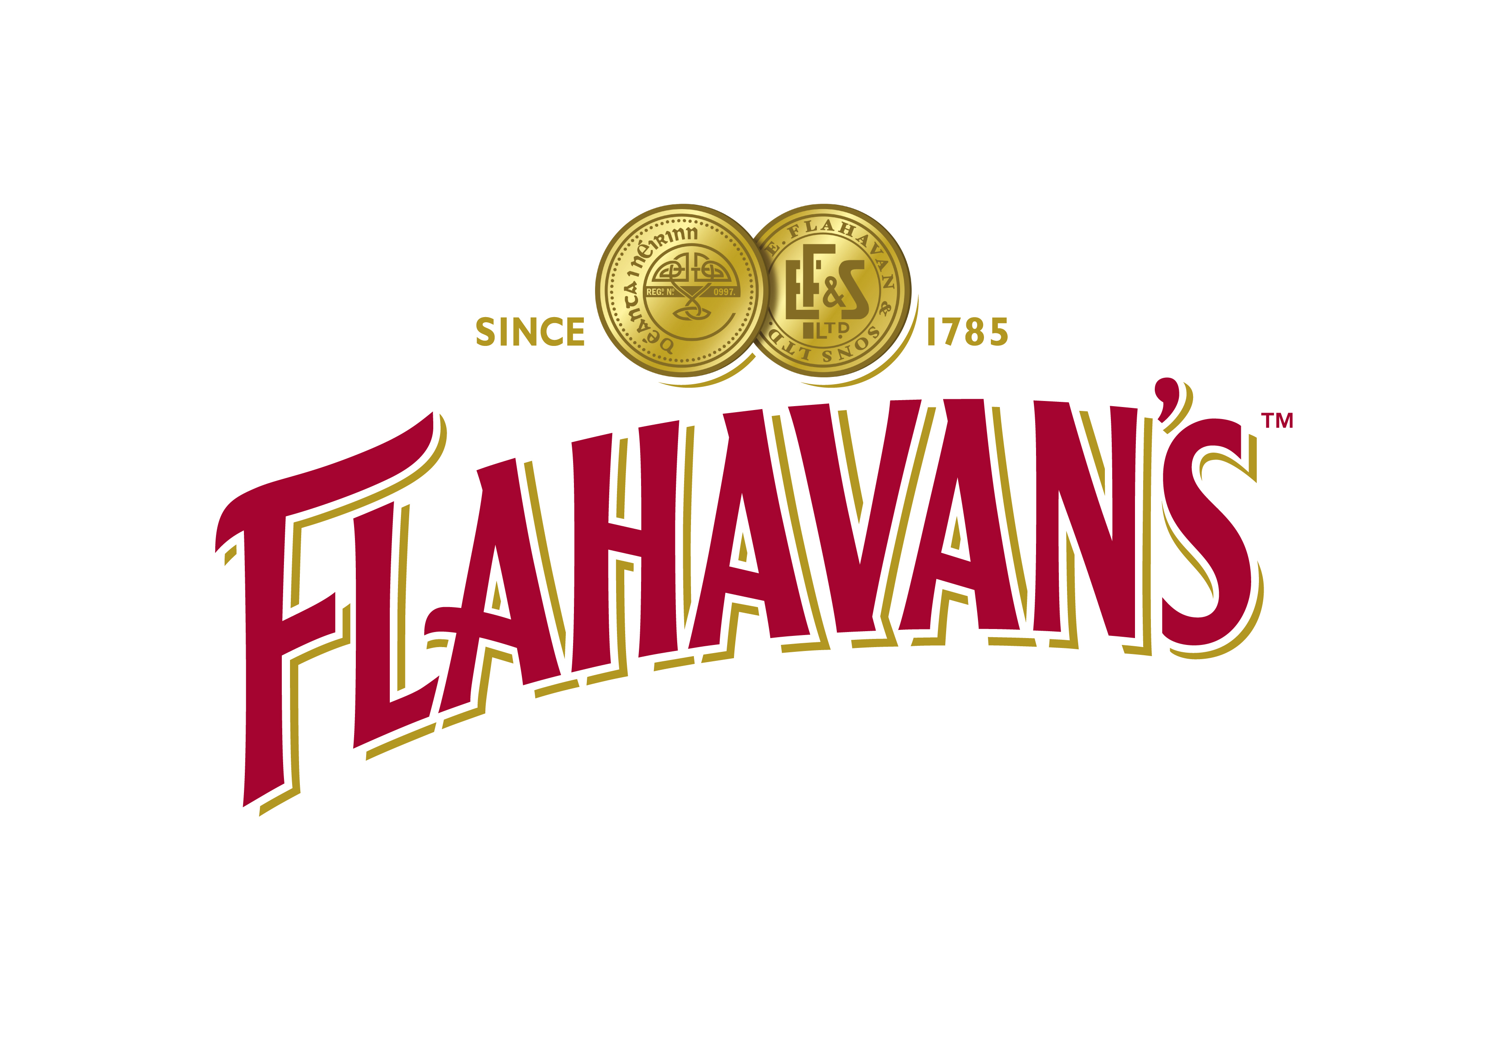
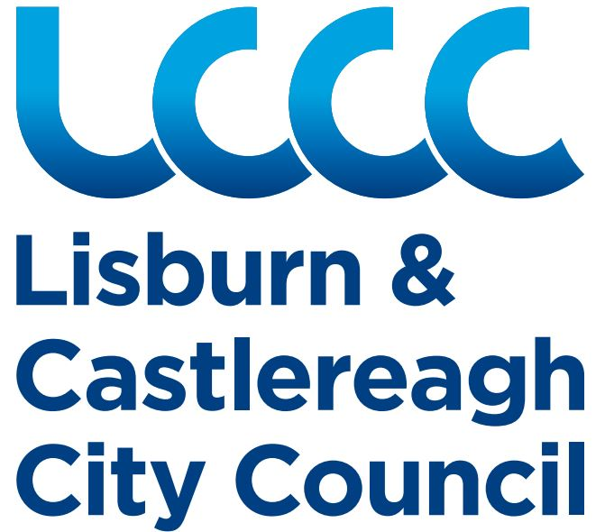
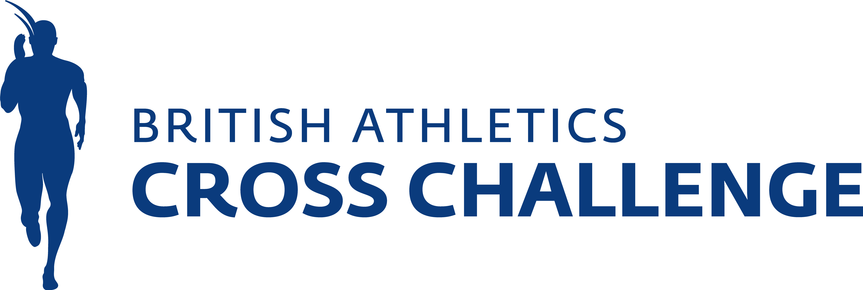


GENERAL INFORMATION

CLOSING DATE:
Paper Entries: Friday 7th January 2022 at 5pm
Online Entries: Tuesday 11th January 2022 at 5pm
Late entries will be taken on the day. These will have an additional fee added to the price.

NO TELEPHONE ENTRIES/AMENDMENTS. Email info@athleticsni.org or post to Athletics House, Old Coach Rd, Belfast, BT9 5PR

- ONLINE ENTRY AVAILABLE ON www.athleticsni.org (Both individual and team entries)

- Cheques/Postal Orders should be made payable to Athletics NI. Credit card payment now available, see back page *NO EURO POSTAL ORDERS PLEASE*

- All Athletes age 13 years or over on 31st Dec 2021 must be registered from 1 April 20. No registration, no entry.

- Teams must field no more than the permitted number. Entries of more than one team in an age group must be marked as “A”, “B” etc in the club name i.e. “City of Lisburn A” etc. Switches may be made between pre-entered athletes on the day (no new entries) For age groups up to U20, all members of a team must be in the same age group race.

- Please note Age Groups are set to keep in line with the UK Cross Challenge, false age entries will be disqualified

Anti Doping & Media:

- All athletes and athlete support personnel are bound by UKA/IAAF Anti Doping Rules (which can be found on the UKA website www.uka.org.uk). In particular, athletes should ensure that they register any use of prescribed medication containing prohibited substances prior to any use or (in emergency cases) immediately after use. For further information please contact the UKA Anti Doping Department on 0121 713 8400.

- By entering you acknowledge that drug testing will be in operation for relevant races at this event. If entering athletes (who are under the age of 18 on the day of event) in U20 or senior open categories, you will be required to submit individual parental consent in case they are selected for testing. It is not normal practice to target U18s for testing, but if their performance merits it, it would not be fair to test some athletes and not others. Consent form is available for sending upon request from Athletics NI, it is also available for download on www.athleticsni.org (IAAF Northern Ireland International Cross Country page in the Events section).

- By entering you confirm you have made guardians of any children/vulnerable adult athletes aware that photography/film footage containing their image may be used by ANI and partners. Media queries/special arrangements & exemption requests to be sent to alan@athleticsni.org.

Entries with full entry fees should be returned to:
International Cross Country, Athletics Northern Ireland, Athletics House, Old Coach Road,
Belfast BT9 5PR
Tel: 028 9060 2707 (0044 28 9060 2707)

World Athletics Northern Ireland International Cross Country
Billy Neill MBE Country Park, Dundonald Saturday 22 January 2022

ENTRY FORM – SENIOR & MASTER

(Please note, national team athletes must also be entered by their club to score)

PLEASE PRINT ALL DETAILS CLEARLY IN BLOCK LETTERS
Details:
Club:
Club Contact:
Address

Tel no/Email

Please include category: S-Senior and M-Master

 | Name | Cat | DOB | Registration Number (2021/22)
1
2
3
4
5
6
7
8
9
10
11
12
13
14

British Athletics Cross Challenge

Entries with fees (cheques to be made payable to Athletics NI) should be returned to:
OFFICE USE ONLY:

AMT: ____________

DATE: ____________

METH: ________________
Athletics Northern Ireland
Athletics House
Old Coach Road, Belfast BT9 5PR

Before Paper Entries: Friday 7th January 2022 at 5pm
Online Entries: Tuesday 11th January 2022 at 5pm

World Athletics Northern Ireland International Cross Country
Billy Neill MBE Country Park, Dundonald Saturday 22 January 2022

ENTRY FORM

Flahavans Porridge Primary School RACE
(Aged P5-P7)

PLEASE PRINT ALL DETAILS CLEARLY IN BLOCK LETTERS

Details:
School:
Contact:
Address

Tel No/Email

Entries: Individual Entry Only

 | Name | DOB |  | Name | DOB
1 |  |  | 2
3 |  |  | 4
5 |  |  | 6
7 |  |  | 8

Entries with fees (cheques to be made payable to Athletics NI) should be returned to:
Athletics Northern Ireland
Athletics House
OFFICE USE ONLY:

AMT: _____________

DATE: _____________

METH: _____________
Old Coach Road, Belfast BT9 5PR
Telephone: 028 9060 2707 Email: info@athleticsni.org

Before Paper Entries: Friday 7th January 2022 at 5pm
Online Entries: Tuesday 11th January 2022 at 5pm

World Athletics Northern Ireland International Cross Country
Billy Neill MBE Country Park, Dundonald Saturday 22 January 2022

ENTRY FORM

GIRLS UNDER 13 RACE
(Aged 11 or 12 on 31st August 2021)

PLEASE PRINT ALL DETAILS CLEARLY IN BLOCK LETTERS

Details:
Club:
Club Colours:
Club Contact:
Address  Tel No. | ………………………………………………………………………………………………….  ………………………………………………………………………………………………….  ……………………………………………Email……………………………………………………

Entries: (enter 8, run 6, score 3)

Team A
 | Name | DOB |  | Name | DOB
1 |  |  | 2
3 |  |  | 4
5 |  |  | 6
7 |  |  | 8

Team B
 | Name | DOB |  | Name | DOB
1 |  |  | 2
3 |  |  | 4
5 |  |  | 6
7 |  |  | 8

Entries with fees (cheques to be made payable to Athletics NI) should be returned to:
Athletics Northern Ireland
OFFICE USE ONLY:

AMT: _____________

DATE: _____________

METH: _____________
Athletics House
Old Coach Road, Belfast BT9 5PR
Telephone: 028 9060 2707 Email: info@athleticsni.org

Before Paper Entries: Friday 7th January 2022 at 5pm
Online Entries: Tuesday 11th January 2022 at 5pm
.

World Athletics Northern Ireland International Cross Country
Billy Neill MBE Country Park, Dundonald Saturday 22 January 2022

ENTRY FORM

BOYS UNDER 13 RACE
(Aged 11 or 12 on 31st August 2021)

Details:
Club:
Club Colours:
Club Contact:
Address  Tel No. | ………………………………………………………………………………………………………….  ………………………………………………………………………………………………………….  ……………………………………………Email……………………………………………………

Entries: (enter 8, run 6, score 3)

Team A
 | Name | DOB |  | Name | DOB
1 |  |  | 2
3 |  |  | 4
5 |  |  | 6
7 |  |  | 8

Team B
 | Name | DOB |  | Name | DOB
1 |  |  | 2
3 |  |  | 4
5 |  |  | 6
7 |  |  | 8

Entries with fees (cheques to be made payable to Athletics NI) should be returned to:
Athletics Northern Ireland
Athletics House
OFFICE USE ONLY:

AMT: _____________

DATE: _____________

METH: _____________
Old Coach Road, Belfast BT9 5PR
Telephone: 028 9060 2707 Email: info@athleticsni.org

Before Paper Entries: Friday 7th January 2022 at 5pm
Online Entries: Tuesday 11th January 2022 at 5pm

World Athletics Northern Ireland International Cross Country
Billy Neill MBE Country Park, Dundonald Saturday 22 January 2022

ENTRY FORM

GIRLS UNDER 15
(Aged 13 or 14 on 31st August 2021)

PLEASE PRINT ALL DETAILS CLEARLY IN BLOCK LETTERS

Details:
Club:
Club Colours:
Club Contact:
Address  Tel No. | ……………………………………………………………………………………………………..….  ………………………………………………………………………………………………………..  ……………………………………………Email……………………………………………………

Entries: (enter 8, run 6, score 3)

Team A
 | Name | DOB |  | Name | DOB
1 |  |  | 2
3 |  |  | 4
5 |  |  | 6
7 |  |  | 8

Team B
 | Name | DOB |  | Name | DOB
1 |  |  | 2
3 |  |  | 4
5 |  |  | 6
7 |  |  | 8

Entries with fees (cheques to be made payable to Athletics NI) should be returned to:
Athletics Northern Ireland
Athletics House
OFFICE USE ONLY:

AMT: _____________

DATE: _____________

METH: _____________
Old Coach Road, Belfast BT9 5PR
Telephone: 028 9060 2707 Email: info@athleticsni.org

Before Paper Entries: Friday 7th January 2022 at 5pm
Online Entries: Tuesday 11th January 2022 at 5pm

World Athletics Northern Ireland International Cross Country
Billy Neill MBE Country Park, Dundonald Saturday 22 January 2022

ENTRY FORM

BOYS UNDER 15
(Aged 13 or 14 on 31st August 2021)

PLEASE PRINT ALL DETAILS CLEARLY IN BLOCK LETTERS

Details:
Club:
Club Colours:
Club Contact:
Address  Tel No. | ………………………………………………………………………………………….…………….  …………………………………………………………………………………………………………  ……………………………………………Email……………………………………………………

Entries: (enter 8, run 6, score 3)

Team A
 | Name | DOB |  | Name | DOB
1 |  |  | 2
3 |  |  | 4
5 |  |  | 6
7 |  |  | 8

Team B
 | Name | DOB |  | Name | DOB
1 |  |  | 2
3 |  |  | 4
5 |  |  | 6
7 |  |  | 8

Entries with fees (cheques to be made payable to Athletics NI) should be returned to:
Athletics Northern Ireland
OFFICE USE ONLY:

AMT: _____________

DATE: _____________

METH: _____________
Athletics House
Old Coach Road, Belfast BT9 5PR
Telephone: 028 9060 2707 Email: info@athleticsni.org
Before Paper Entries: Friday 7th January 2022 at 5pm
Online Entries: Tuesday 11th January 2022 at 5pm

World Athletics Northern Ireland International Cross Country
Billy Neill MBE Country Park, Dundonald Saturday 22 January 2022

ENTRY FORM
FEMALE IAAF U20 (on 31 Dec 2022) &
GIRLS UNDER 17 (Aged 15 or 16 on 31st August 2021)

PLEASE PRINT ALL DETAILS CLEARLY IN BLOCK LETTERS

Details:
Club:
Club Colours:
Club Contact:
Address  Tel No. | ……………………………………………………………………………………………………..….  …………………………………………………………………………………………………………  ……………………………………………Email……………………………………………………

Entries: (enter 8, run 6, score 3)

Team A
 | Name | DOB |  | Name | DOB
1 |  |  | 2
3 |  |  | 4
5 |  |  | 6
7 |  |  | 8

Team B
 | Name | DOB |  | Name | DOB
1 |  |  | 2
3 |  |  | 4
5 |  |  | 6
7 |  |  | 8

Entries with fees (cheques to be made payable to Athletics NI) should be returned to:
Athletics Northern Ireland
Athletics House
OFFICE USE ONLY:

AMT: _____________

DATE: _____________

METH: _____________
Old Coach Road, Belfast BT9 5PR
Telephone: 028 9060 2707 Email: info@athleticsni.org
Before Paper Entries: Friday 7th January 2022 at 5pm
Online Entries: Tuesday 11th January 2022 at 5pm

World Athletics Northern Ireland International Cross Country
Billy Neill MBE Country Park, Dundonald Saturday 22 January 2022

ENTRY FORM

BOYS UNDER 17 RACE
(Aged 15 or 16 on 31st August 2021)

PLEASE PRINT ALL DETAILS CLEARLY IN BLOCK LETTERS

Details:
Club:
Club Colours:
Club Contact:
Address  Tel No. | ………………………………………………………………………………………………..……….  …………………………………………………………………………………………………………..  ……………………………………………Email……………………………………………………

Entries: (enter 8, run 6, score 3)

Team A
 | Name | DOB |  | Name | DOB
1 |  |  | 2
3 |  |  | 4
5 |  |  | 6
7 |  |  | 8

Team B
 | Name | DOB |  | Name | DOB
1 |  |  | 2
3 |  |  | 4
5 |  |  | 6
7 |  |  | 8

Entries with fees (cheques to be made payable to Athletics NI) should be returned to:
Athletics Northern Ireland
OFFICE USE ONLY:

AMT: _____________

DATE: _____________

METH: _____________
Athletics House
Old Coach Road, Belfast BT9 5PR
Telephone: 028 9060 2707 Email: info@athleticsni.org

Before Paper Entries: Friday 7th January 2022 at 5pm
Online Entries: Tuesday 11th January 2022 at 5pm

World Athletics Northern Ireland International Cross Country
Billy Neill MBE Country Park, Dundonald Saturday 22 January 2022

ENTRY FORM

MENS UNDER 20 CHAMPIONSHIPS

(Under IAAF Rules – under the age of 20 on 31 December 2022)

PLEASE PRINT ALL DETAILS CLEARLY IN BLOCK LETTERS
Details:
Club:
Club Colours:
Club Contact:
Address  Tel No. | …………………………………………………………………….…………………………….  …………………………………………………………………………………………………..  ……………………………………………Email……………………………………………………

Entries: (enter 10, run 8, score 3)
Team A
 | Name | DOB |  | Name | DOB
1 |  |  | 2
3 |  |  | 4
5 |  |  | 6
7 |  |  | 8
9 |  |  | 10

Team B
 | Name | DOB |  | Name | DOB
1 |  |  | 2
3 |  |  | 4
5 |  |  | 6
7 |  |  | 8
9 |  |  | 10
OFFICE USE ONLY:

AMT: _____________

DATE: _____________

METH: _____________
Entries with fees (cheques to be made payable to Athletics NI) should be returned to:
Athletics Northern Ireland
Athletics House
Old Coach Road, Belfast BT9 5PR
Telephone: 028 9060 2707 Email: info@athleticsni.org
Before Paper Entries: Friday 7th January 2022 at 5pm
Online Entries: Tuesday 11th January 2022 at 5pm

