Horizontal Jumps & Sprints

Event Group Development Sessions

Athletics Northern Ireland will provide weekly horizontal sprints and jumps development sessions delivered by Commonwealth Games Athlete, Jumps Specialist and International Sprints Coach- Adam McMullen. Beginning on October 24th, sessions for athletes aged 14-20 years old will take place on a Saturday at Ulster University, Jordanstown. Closer to the outdoor competitive season these sessions will move outdoors to Mary Peters Track.

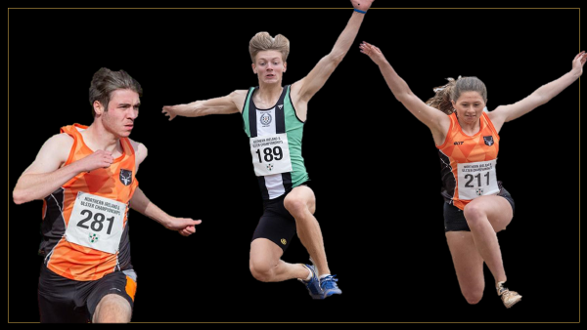

Athletics Northern Ireland aim to provide opportunities for teenage athletes to train and learn together on a regular basis and have upskilled a number of event specialist coaches to support this. Ultimately, we aim to see technically and physically well-prepared and robust young jumpers and sprinters progress to represent Northern Ireland as Senior athletes. This will require consistent training, pursuing the highest level of competition available and a keen approach to strength and conditioning.

These sessions aim to introduce more event specific training for athletes who have been gaining experience in clubs and wish to individualize their technical and physical preparation training further. The training emphasis will develop through the year and sessions for jumpers will include a functional movement based warm up, some form of sprinting either acceleration of max velocity, bounding, short approach jumps and full approach jumps.

- Sessions will take place between 14.00 and 17.00 at a cost of £8 per session with 9 expected sessions in term 1 between 24 October and 19 December.
- There will be discounts or fee waivers for Youth Academy athletes if this is a primary session for them.
- Coaches who wish to attend for the purposes of upskilling themselves will not be charged to attend but should email in advance to request this.
- Saturday 14.00 – 17.00 Sprints and jumps will make up the first two hours with a gym-based Strength & Conditioning session taking place from 16.00 – 17.00 at Ulster University Jordanstown.

Application form

Please complete the following:

Name:
DOB:
School or University Year in September 2020:
Coach/Club (if any):
Home Town:
Training Experience or normal weekly training schedule;

Normal Training Location:
Main event
2018 PB: date;
2019 PB: date;
2020 PB: date;

Secondary Event
2018 PB: date;
2019 PB: date;
2020 PB: date;

Spaces will be limited to allow us to meet ideal coach to athlete ratios and applications will be assessed based on performance, potential and availability to engage. Where an athlete already works with a jumps/sprints coach but wishes to supplement their normal training with this specialist session they should first speak to their coach about it. Coach-athlete pairs who would like to attend together to follow the training plan, upskill and benefit from working together in a group are welcome to apply.

After review of the applications there will be a selection process and successful applicants will be contacted. An offer will be made during September to allow for an end of October start. Once an offer is made to athletes, they will be able to assess that offer and their availability to attend at the proposed times before signing up to the online entry system to provide emergency contact details and make the session payments.

Applications may be typed or handwritten (& scanned) but must be emailed to tom.reynolds@athleticsni.org by 5pm 12th October 2020

