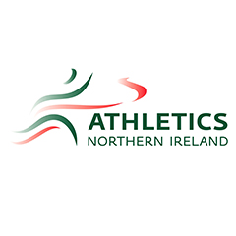

**Throws (Javelin & Shot)**

**Event Group Development Sessions**

*Athletics Northern Ireland will provide weekly throws development sessions delivered by Laura Kerr, GB&NI and Irish Team Coach. Laura has previously worked with Jack Magee (IUAA Javelin Record Holder & British Universities Medalist- 66.42m and Katie O’Connor-European U20 Heptathlon Silver Medalist and NI Javelin Record Holder 52.93m.)*

*Beginning on October 24th 2020 sessions for athletes aged 14-20 years old will take place on a Saturday at Ulster University, Jordanstown. Sessions will include technical development, medicine ball training, event specific mobility and strength training. Closer to the competitive season (March) these sessions will move outdoors to Mary Peters Track.*

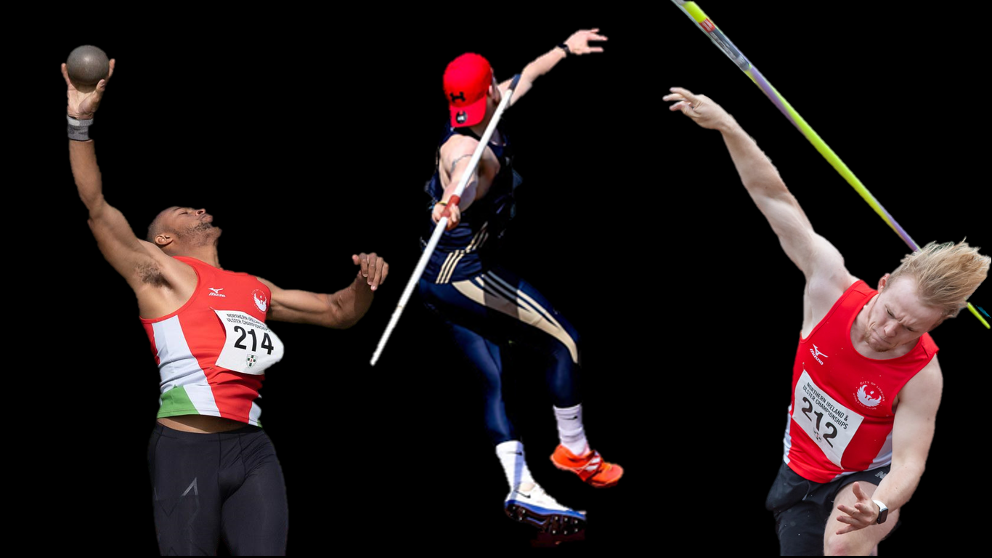

Athletics Northern Ireland aim to provide opportunities for teenage athletes aspiring to one day represent NI & Ulster as senior athletes to learn and train together on a regular basis and have upskilled a number of event specialist coaches to support this. Ultimately, we aim to see technically and physically well-prepared and robust young throwers progress to represent Northern Ireland as Senior athletes. This will require consistent training, pursuing the highest level of competition available and a keen approach to strength and conditioning.

These sessions aim to introduce more event specific training for athletes who have been gaining experience in clubs and wish to individualize their technical and physical preparation training further.

The training emphasis will develop through the year and with a later peaking age in throws long term athlete development will be kept in mind. Sessions for throwers will therefore include: a movement skill based warm up, mobility, plyometrics, medicine ball throwing, technical drills and sprints. There will also be a strength development session at the end.

* **Sessions will take start at 1pm for shot putters, 2pm for javelin throwers and will include gym-based strength & conditioning 4-5pm to conclude.**
* **The cost will be £8 per session with 9 expected sessions in term 1 beginning on 24th October running until 19th December. Term 2 will commence in January.**
* **Were this is a key session for a Youth Academy Athlete a fee waiver or discount will be organized.**
* **Coaches who wish to attend for the purposes of upskilling themselves will not be charged to attend but should email in advance to request this.**

**Application form**

**Please complete the following:**

*Name:*

*DOB:*

*School or University Year in September 2019:*

*Coach/Club (if any):*

*Home Town:*

*Training Experience or normal weekly training schedule;*

*Normal Training Location:*

*Main event*

*2018 PB: date: Date; Implement Weight:*

*2019 PB: date; Date; Implement Weight:*

*2020 PB: date; Date; Implement Weight:*

*Secondary Event*

*2018 PB: date; Date; Implement Weight:*

*2019 PB: date; Date; Implement Weight:*

*2020 PB: date; Date; Implement Weight:*

After review of the applications that are received there will be a selection process and successful applicants will be contacted with further information so that they can pay the registration fee online and provide emergency contact details etc.

Spaces will be limited to allow us to meet ideal coach to athlete ratios for technical events and applications will be assessed based on performance, potential and availability to engage.

Where an athlete already works with a throws coach but wishes to supplement their normal training with this specialist session they should first speak to their coach about it. Coach-athlete pairs who would like to attend together to follow the training plan, upskill and benefit from working together in a group are welcome to apply and make note of this when completing the form above.

**Applications must be typed and emailed to** [**laura@athleticsni.org**](mailto:laura@athleticsni.org) **by 12th October 5pm**