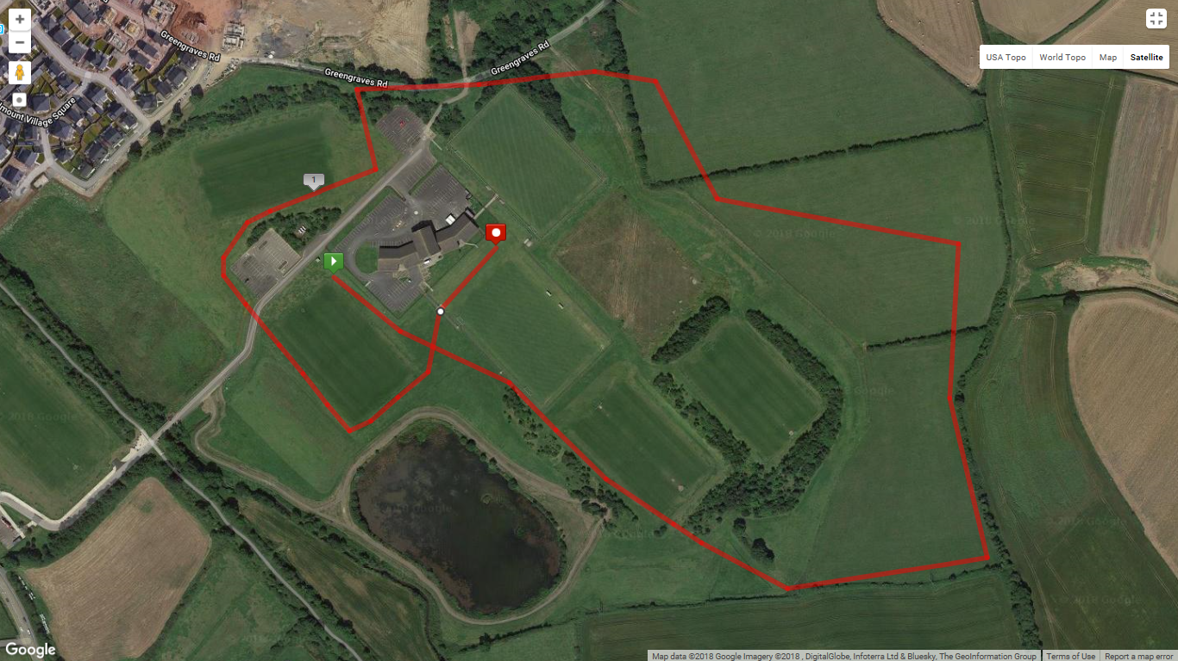

**Red Lap = 2000m**

**Yellow Lap = 1000m** – (Only used for Primary School, and U15 races)

*Distance of lap is Approximate

Finish

Start