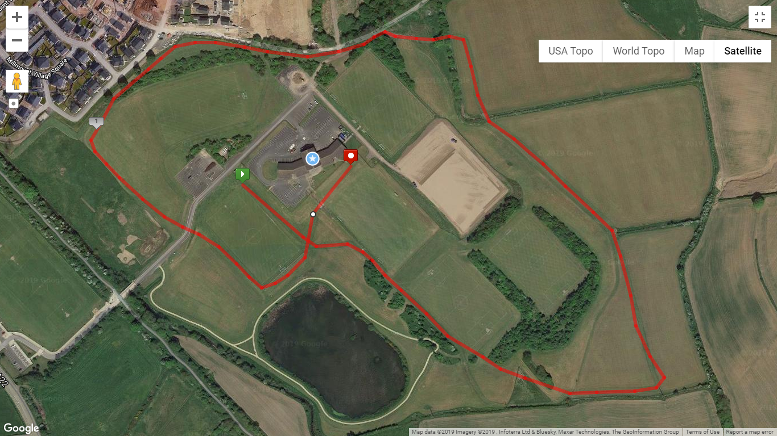

FINISH

START

**U11 (Girls and Boys): 1200m** – 1 Yellow Lap + Finish Straight

**U13 (Girls and Boys): 2000m –** 1 Red Lap

**U15 (Girls and Boys): 3000m** – 1 Yellow Lap + 1 Red Lap

**U17 & U19 Girls: 4000m** – 2 Red Laps

**U17 Boys**: **4500m** - 2 Red Laps +

**Bobby Rea Memorial Races:**

**Women & M60+: 5000m** – 1 Yellow + 2 Red Laps

**Men:** 8000m – 4 Reds Laps

**Red Lap = 2000m**

**Yellow Lap = 1000m**

**\*Distance of Lap is Approximate**