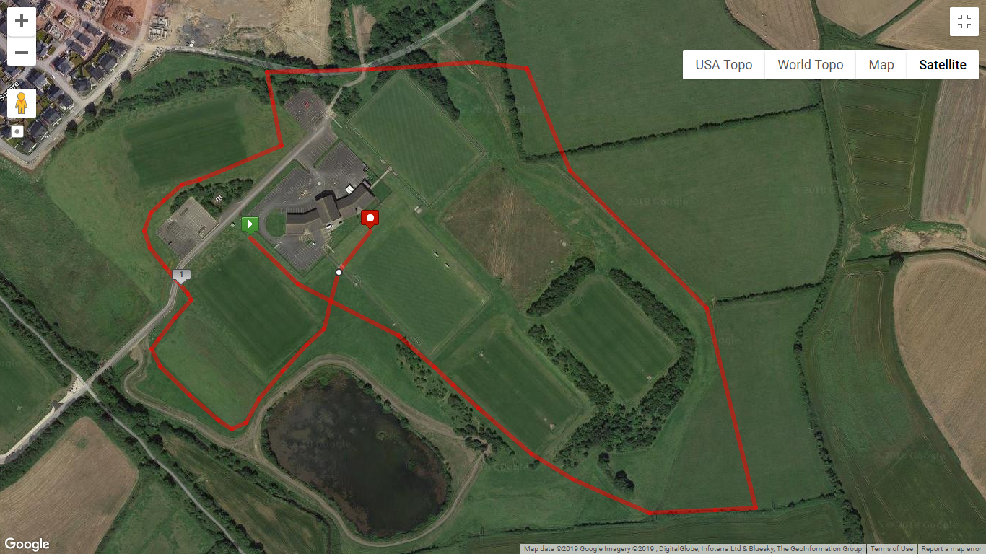

Finish

Start

**Red Lap = 2000m**

**Yellow Lap = 1000m** – (Only used for Primary School, and U15 races)

*Distance of lap is Approximate

**U11 (Girls & Boys)** – 1200m – 1 Yellow Lap + Finish Straight

**U13 (Girls & Boys)** – 2000m – 1 Red Lap

**U15 (Girls & Boys)** – 3000m – 1 Yellow Lap + 1 Red Lap

**U17 & U19 Girls** – 4000m – 2 Red Laps

**U17 Boys** – 4500m – TBC

**Bobby Rea Women & Male 60+** – 5000m – 2 Red Lap + 1 Yellow Lap

**Bobby Rea Men** – 8,000m – 4 Red Laps