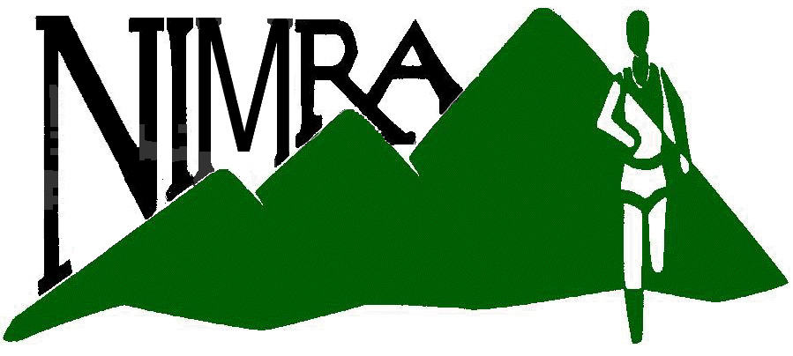 | Athletics Northern Ireland | Permit No: ...................  Issued: ......................... | 

MOUNTAIN RACE PERMIT APPLICATION FORM

Part A TO BE COMPLETED BY THE CLUB OR ORGANISATION
Part B TO BE COMPLETED BY THE ORGANISER

Part A

EVENT _____________________________________ DATE OF EVENT _______________

ORGANISATION ______________________________________________________________

With the authority of and on behalf of the above named organisation, I apply for a Race Permit and for the above named event to be registered as approved by the UK Athletics.
I undertake on behalf of the above named organisation that the race will be conducted in conformity with the UK Athletics Rules of Competition and Safety Requirements for Fell Races as well as relevant ANI & NIMRA competition rules.

In signing this declaration your attention is drawn particularly to the rule that requires an additional entry fee of £1 over and above the general entry fee. This applies for all entries accepted from unattached/unregistered runners who are not current members of Athletic Clubs affiliated directly or indirectly to UK Athletics. The full amount of such additional entry fees must be remitted to the relevant Athletics Regional Permit Officer within one month of the date of the race.

SIGNED ___________________________ DATE ____________________

APPLICANTS FULL NAME _______________________

APPLICANTS POSITION ______________________________

APPLICANTS ADDRESS _____________________________

_____________________________________

DAY TEL No ____________ EVENING TEL No _______________ Mobile No _____________

EMAIL ______________________________________________________

EVENT CONTACT (If different from above) _______________________

ADDRESS __________________________________________________

DAY TEL No ____________________ EVENING TEL No _____________________

EMAIL _____________________________________________________

Part B PLEASE PROVIDE FULL DETAILS OF PROPOSED EVENT AS FOLLOWS

EVENT HEADQUARTERS __________________________________________________________

SENIOR RACE

DISTANCE ___________ ASCENT __________

START TIME ___________________

START LOCATION ______________________________ FINISH LOCATION _________________

Grid reference numbers to be included for start and finish locations.

BRIEF COURSE DESCRIPTION.

(a map showing the route should be enclosed for new races or ones with substantially revised routes)

JUNIOR RACES (under 18)

DISTANCE ______________ ASCENT _____________

START TIME ___________________

START LOCATION ______________________________ FINISH LOCATION _________________

Grid reference numbers to be included for start and finish locations.

BRIEF COURSE DESCRIPTION.

(a map showing the route should be enclosed for new races or ones with substantially revised routes)
Races for junior runners should comply with the maximum distances specified in UKA Rule 410.

ALL RACES

CLOSING DATE FOR ENTRIES ______________ [If applicable) ENTRIES ON DAY? YES / NO

ENTRY FEES: ATTACHED: £ _______ UNATTACHED [including additional £1 levy:] £ ______

On behalf of the Club or Organisation I confirm the following in respect of the event (please tick the relevant boxes):

Planning and Access

UK Athletics Rules of Competition and Safety Requirements will be complied with

Permission has been obtained from landowners to cross or access land

Access to the venue, the start and finish areas and the venue area will be safe and able to cope with the expected numbers and conditions

Environmental protection has been assessed to minimise any adverse affect on the venue or race route areas

Toilets are provided or are nearby for all championship events

The Course

Distance and total ascent have been advertised

The course will be signed, taped and marshalled to a standard that will ensure runners keep to the approved route or a declaration will be made that navigation skills are required

Marshals will be briefed and visible to race entrants

The course will be cleared of tape, signs, litter, etc. as soon as practical

Medical Support

Suitable provision of first aid and medical support has been assessed according to the severity and nature of the route, distance, size of field and likely temperature

Risk Assessment

The risks have been assessed in accordance with UKA Safety Requirements for Fell Races and any risks associated with the event have been identified and planned accordingly

Various options for alternative bad weather routes should be considered and be possible to implement at short notice. Athletes should be given as much notice as is feasible of any course changes.

Permit Matters

The unattached entry levy will be shown on event literature

Within one month of the event the Regional Mountain Permit Officer will be sent a copy of the results and a cheque for any unattached entry levies

An accident report form should be completed if any accident or similar incident occurs.

Signed …………………………………… Print Name ……………………………… Date …………………

Permits are issued free to organisations affiliated to the Athletics NI.

If required, as indicated above, this application must be accompanied by a map of the course showing the race route

Public liability insurance up to a maximum liability of £10,000,000 on any one occurrence is automatically given to any mountain race for which a UK Athletics permit is issued. An excess of £500 is payable on the first and each subsequent claim made under the liability insurance.

WHEN COMPLETED, THIS FORM SHOULD BE SENT TO YOUR REGIONAL PERMIT OFFICER AS DETAILED BELOW:

Ian Taylor, 52 Bladon Drive, Belfast BT9 5JN (tel 028 9028 0790, email: ir.taylor@ntlworld.com )

Guidance on UKA Rules, risk assessment and Safety may be obtained from the above.
DATA PROTECTION. The information you provide will be held on a database and will be held in the strictest confidence.

