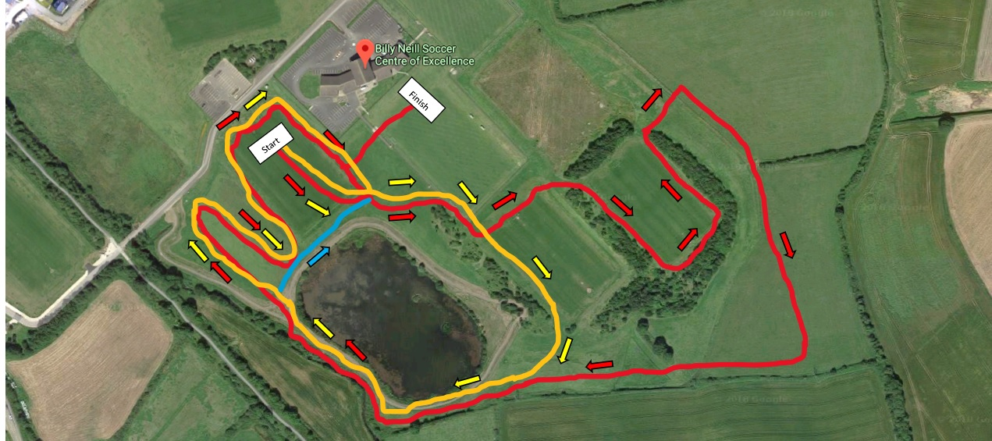

**Red Lap = 2000m**

**Yellow Lap = 1000m**

*Distance of lap is Approximate

**NI & Ulster Even Age Groups Championships & Bobby Rea Cross Country **

**U10 (Girls & Boys)** – 1000m – 1 short Yellow Lap (blue line)

**U12 (Girls & Boys)** – 1500m – 1 Yellow Lap

**U14 (Girls & Boys)** – 2500m – 2 Yellow Laps

**U16 (Girls & Boys)** – 3500m – 1 Yellow Lap + 1 Red Lap

**U18 Girls** – 4000m – 2 Red Laps

**U18 Boys** – 5000m – 1 yellow & 2 red laps

**U20 & Senior & Masters Women & Men O60+** – 6000m – 3 Red Laps

**U20 & Senior & Masters Men** – 8000m – 4 Red Laps