**Red Lap = 2000m**

*Distance of lap is Approximate

**NI & Ulster Intermediate and Masters Cross Country 2024 **

**Masters Women & M65+** – 4000m – 2 Red Laps

**Intermediate Women** – 4000m – 2 Red Laps

**Masters and Intermediate Men** – 8000m – 4 Red Laps

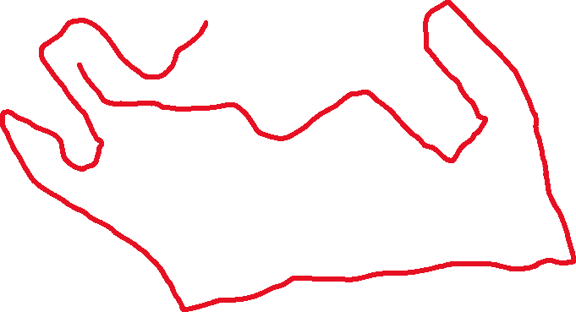

**Start**

**Finish**

