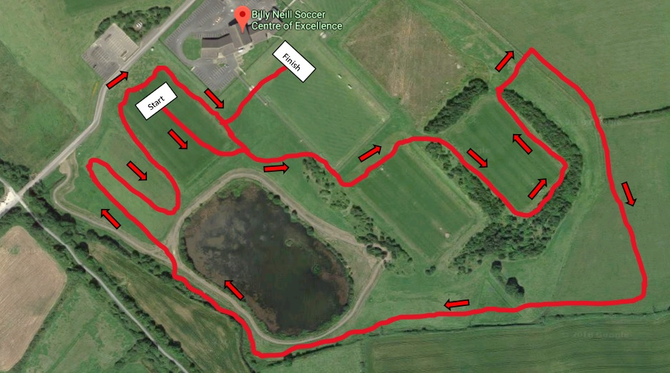

**Red Lap = 2000m**\*

**NI & Ulster Senior Cross Country Championships**

**Senior Women**– 6k – 3 Red Laps

**Senior Men** – 12k – 6 Red Laps