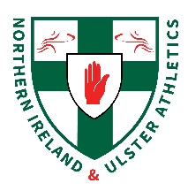
NI & Ulster 10,000m & Relay Championships
Saturday 18th September 2021
Antrim Forum
Provisional Timetable
Time | Event
10am | Registration
11am (4x100m) | U13 Girls Final
 | U13 Boys Final
 | U15 Girls Time Trial
 | U15 Girls Time Trial
 | U15 Boys Final
 | U17 Boys Final
 | U17 Girls Final
 | Senior Women Final
 | Senior Men Final
12 noon (4x300m) | U15 Girls Time Trial
 | U15 Girls Time Trial
 | U15 Boys Final
 | U17 Girls Final
12:45pm (4x400m) | U17 Boys Final
 | Senior Men Final
 | Senior Women Final
1.15pm | 10,000m Men & Women

