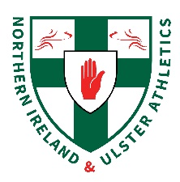
NI & Ulster Intermediate & Masters Cross Country Championships
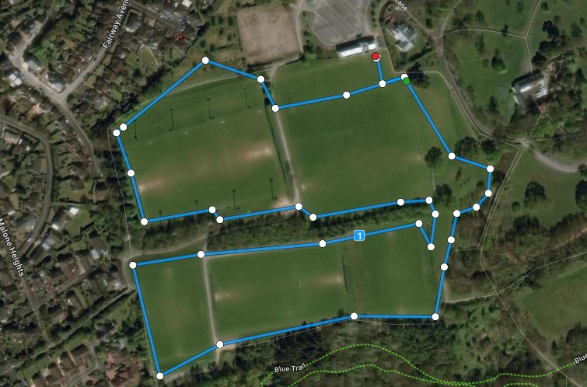
Sunday 30th January 2022
FINISH
START
1 lap = 2000m approx

