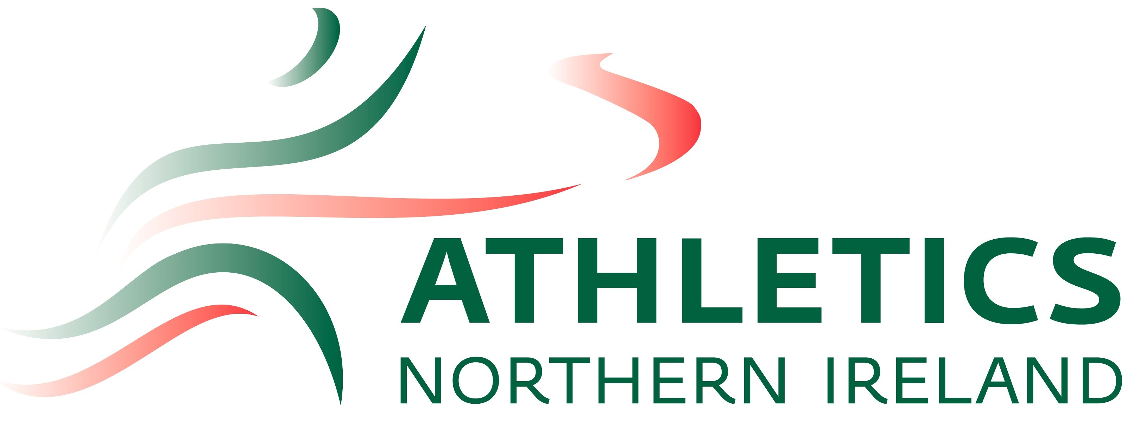

Athletics NI Open Meet- May 2023

Mary Peters Track, Belfast
24th May 2023

5.30pm REGISTRATION

Track |  | Field
6:30pm | U18 & Senior Women’s 100m Hurdles (U18 76.2cm) | 6:30pm | Men & Women’s Hammer
6:40pm | Men’s 800m- Race 1 |  | Men & Women’s Triple Jump
6:55pm | Men’s 800m- Race 2
7:10pm | Women’s 800m
7:15pm | Men’s 5000m | 7:15pm | Men & Women’s Shot Put
7:40pm | Women’s 200m
7:45pm | Men’s 200m Race 1 | 7:45pm | Senior & U18 Men’s & Senior Women’s Javelin
7:50pm | Men’s 200m Race 2

Notes:
- Field Events will be given 4 attempts each
- Athletes are allowed to bring up to two personal implements, and these must be given into the registration for weighing.

