Relay Entries: How to Guide
Enter The Teams
Step 1: Click on the green ‘Relay Team Entries’ button to choose which teams you would like to enter and follow the steps on the screen to go through to payment.
Please note once you start this step, you will be assigned at the Team Manager for your club, and therefore any additional entries or amendments, must be done by the same person. If another member of your club tries to enter another team, the system will present with an error message.
Team Declarations
Step 1: Follow the link from the Athletics NI website to the Online Entry system, and click on the green ‘Team Declarations’ button:
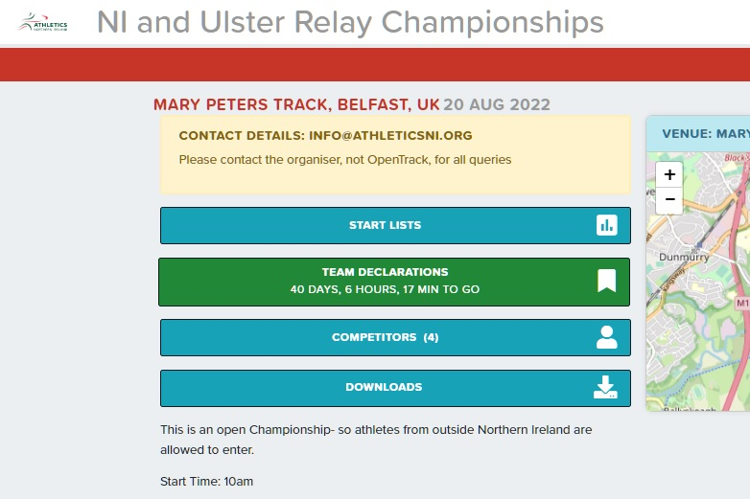

Step 2: Search for your club in the lookup menu and once you have selected your club, click the enter button:
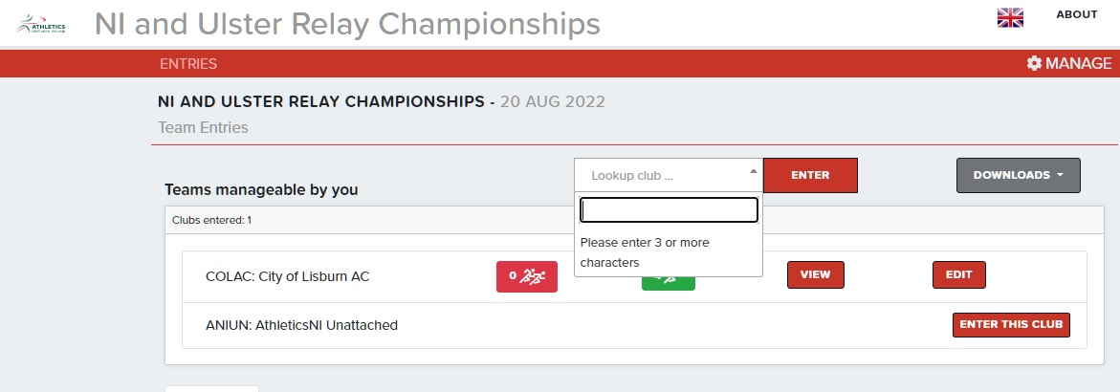

Step 3: You will then be taken to the Relay Team page, where you can choose from the relay teams on the left hand side of the screen, and from your listed athletes on the right hand side. Choose which relay you would like to enter (for this example we have used ‘Senior Women’s 4x100m’, then click the ‘+Add Team’ button:
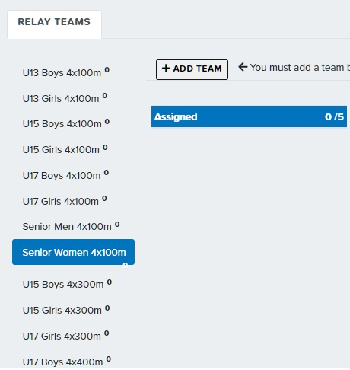
2: Click ‘Add Team’

1: Select which team you would like to enter

Step 4: You will then be able to choose from the athlete lists on the right hand side of the screen. Teams of 4 can be selected, with 1 reserve named.
Step 5: Once you are happy with your teams- click the red ‘Save/ Continue to Basket’ button to make the payment.

*For any clubs NOT affiliated to Athletics NI, you may not be able to do your Team Declaration online, as this asks clubs to choose members from a drop-down list of those available. As long as you have completed the payment section, your entry will still go through.

