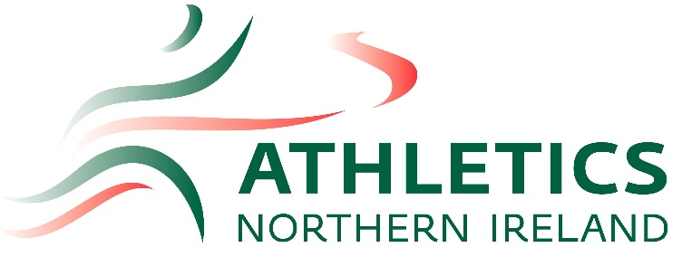

ANI July Open Meet

Mary Peters Track, Belfast
26th July 2026

9.00am REGISTRATION

Time | Track | Field
11:00am |  | U12 Girls Long Jump
 |  | U18 & Senior Women’s Hammer
11:10am | U12 Girls 60m
11:20am | U12 Boys 60m
11:30am | U14 Girls 80m
11:40am | U14 Boys 80m | U12 Boys Long Jump
11:50am | U16 Girls 100m
12:00pm | U16 Boys 100m
12:20pm | Wheelchair 100m | U14 Boys Long Jump
 |  | U14 & U16 Boys Hammer
12:30pm | U18 & Senior Women’s 100m
12:40pm | U18 & Senior Men’s 100m
12:50pm | Frame Running 100m
1:00pm | U12 Girls 600m | U14 Girls Long Jump
 |  | U14 & U16 Girls Hammer
1:05pm | U12 Boys 600m
1:10pm | Wheelchair 800m
1:15pm | U14 Girls 800m
1:30pm | U14 Boys 800m
1:40pm | Frame Running 400m
1:50pm | U16 Girls 1500m
2:00pm | U16 Boys 1500m | U16 Girls & Boys Triple Jump
 |  | U18 & Senior Men’s Hammer
2:20pm | U18 & Senior Women 1500m
2:30pm | U18 & Senior Men 1500m
2:40pm |  | U18 & Senior Men & Women’s Triple Jump

